TOPIC ONE
KEEPING POULTRY AND BEES
POULTRY KEEPING
Qn: What is poultry?
Poultry are domestic birds or fowls.
Qn: What is poultry keeping?
Poultry keeping is the rearing of domestic birds or fowls.
Qn: Explain the following terms as used in poultry.
(a) A chick
A chick is a young chicken.
(b) A hen
A hen is a female chicken.
(c) A cock
A cock is a male chicken.
(d) A pullet
A pullet is a young female chicken.
(e) A cockerel
A cockerel is a young male chicken.
(f) A capon
A capon is a castrated cock.
(e) Culling
Culling is the removal of sick and unproductive birds from the flock.
(h) Candling
Is the viewing of an egg in bright light to know if it is fertilized or not.
(i) Incubation
Incubation is the providing of necessary conditions to a fertilized egg to enable it hatch into a chick.
(j) Incubator
Is a machine that provides necessary conditions to eggs until they hatch into chick.
(k) Brooding
This is the providing of special care to chicks below 8 weeks.
(l) A brooder
Is a special structure where chicks below 8 weeks are kept.
(m) A broody hen
Is a hen incubating its eggs.
(n) Preening
Is the act of birds cleaning and arranging their feathers.
(o) Moulting
Is the shedding of old feathers from the body of a bird.
(p) Debeaking
Is the shortening of the upper beak of a bird.
Qn: Give any two reasons why people keep poultry.
- To get eggs
- To get meat
- To sell and get money
- To get manure
Qn: Identify any two products got from poultry.
- Eggs
- Meat
- Feathers
- Manure
Qn: Mention any three types of poultry / Examples of poultry.
- Hen - Guinea fowl - Geese - cock
- A parrot - pigeon - Turkey - Ducks
External features of domestic fowls.
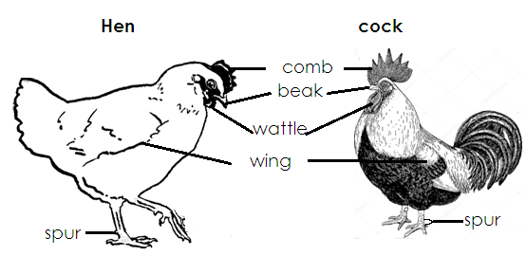

Functions of some parts
(a) Beak
- For protection
- For picking food
- For pecking food
- For building nests
(b) Comb and wattle
For identification
(c) Spur
For protection
(d) Feathers
- To keep the body of a bird warm.
- For flying
- For identification
- For incubating eggs
- For brooding chicks
- They give shape to the bird.
(e) Toes and claws
- For scratching the ground when looking for food.
- For protection.
Ducks
- Ducks have broad and spoon shaped beaks that help them catch small animals in water.
- Ducks have webs between their toes which help them to swim in water.
- Ducks are swimming birds.
Meat breeds of ducks
- Pekin - Aylesbury - Khaki Campbell duck - Muscovy
- Roven
Qn: Give any two structural differences between a hen and a cock.
- A hen has a small comb while a cock has a big comb.
- A hen has a small wattle while a cock has a big wattle.
- A hen has dull short neck feathers while a cock has bright and long neck and tail feathers.
- A hen has small earlobes while a cock has big earlobes.
- A hen has a short spur while a cock has a long spur.
Qn: State any two reasons for the differences between a hen and a cock.
- A cock protests the chicks and a hen.
- A cock fights and frightens other cock to control the territory.
- A cock attracts the hens.
FEATHERS
Qn: Mention any four uses of feathers to a bird.
Types of feathers.
(i) Quill or flight feathers.
(ii) Body or covert feathers
(iii) Down feathers
(iv) Filoplume feathers
QUILL FEATHERS
Qn: Mention two body parts of a bird where quill feathers are found.
- Wings
- Tail
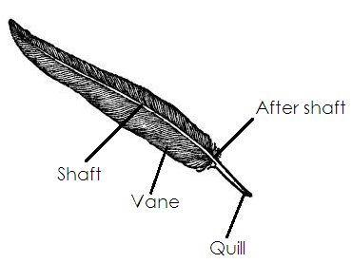
Illustration showing the quill feather.

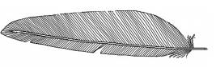
BODY / COVERT FEATHERS
- They keep the bird warm.
- They give the bird
Illustration showing the body feather.

DOWN FEATHERS
- These are feathers that the chick is hatched with.
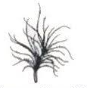
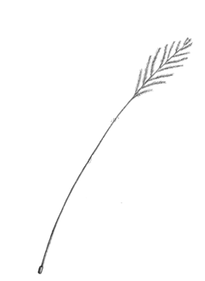
- They keep the chick warm.

FILOPLUME FEATHERS
- They are the smallest feathers found nearest to the skin of a bird.
- They are seen after removing the body and down feathers.
Illustration showing a filoplume feather

BREEDS OF CHICKEN
Qn: What is a breed of chicken?
A breed of chicken is a class of chicken having specific characteristics.
Types of breeds of chicken
- Local breeds
- Exotic breeds
- Cross breeds
- Hybrids
Local breeds of chicken
These are chicken that exist in a country without being brought from outside countries.

Qn: State any three characteristics of local breeds of chicken.
(i) They are more resistant to diseases.
(ii) They are more resistant to harsh weather changes.
(iii) They grow slowly
(iv) They have different colours
(v) They are different in size.
(vi) They lay fewer eggs.
Exotic breeds of chicken
These are chicken that have been imported into E. African from outside countries.
Qn: Write down any three characteristics of exotic breeds of chicken.
(i) They are not resistant to diseases.
(ii) They are not resistant to harsh weather changes
(iii) They grow quickly
(iv) They have the same colour.
(v) They have the small size.
(vi) They provide high quantity of products.
Qn: Give three examples of exotic breeds of chicken.
- White leghorn
- Brown egger
- Rhode Island red
- Minorca
- Light Sussex
Cross breeds
- These are chicken got by mating the local breed of chicken with exotic breeds of chicken.
Qn: What is cross breeding?
Cross breeding is the mating of the local breed with the exotic.
Qn: Identify one way of improving on the local breeds of chicken.
(i) By cross breeding
(ii) By selective breeding
Qn: State any two importance of crossbreeding.
- It improves on the quality of birds.
- It improves on the productivity of birds.
- It encourages fast growth in birds.
TYPES OF CHICKEN
Qn: What is a type of chicken?
A type of chicken is a class of chicken kept for a specific purpose.
These are three types chicken namely:-
(i) Layers or light breeds
(ii) Broilers or table birds
(iii) Dual purpose chicken.
LAYERS
These are chicken that are mainly kept for egg production.
Qn: Write down any two examples of layers or light birds.

(i) White leghorn
(ii)Ancona
(iii) Minorca
(iv) Brown eggers
(v) Sykes

BROILERS
These are chicken that are mainly kept from meat production.
Examples of broilers birds.

(i) Black australorp
(ii) Plymouth rock
(iii) Newhampshire
(iv) Rhode Island Red
(v) Light Sussex

Dual purpose Birds
These are chicken kept for both meat and egg production.
Examples of dual purpose chicken
- Ross birds
- Shavers
SYSTEM OF KEEPING POULTRY
There are four systems of keeping poultry namely.
(a) Free range system
(b) Deep litter system
(c) Battery / cage system
(d) Fold / pen system
1. FREE RANGE SYSTEM
This is a system where birds are left to move about and look for their food.
Advantages of free range system
(i) It is cheap
(ii) Birds get enough exercise
(iii) Birds eat food of their choice
(iv) Birds feed on a balanced diet.
(v) The farmer gets time to do other activities.
(vi) Poultry vices are reduced.
Disadvantages of free-range system
(i) Birds can easily get lost.
(ii) Birds can easily get stolen
(iii) Birds can easily be eaten by wild animals.
(iv) Birds can destroy people’s property.
(v) It is not easy to collect eggs.
(vi) It is not easy to control diseases.
2. DEEP LITTER SYSTEM
This is a system where birds are kept in a house all the time.
Advantages of deep litter system
(i) Birds cannot easily get lost.
(ii) Birds cannot easily be stolen.
(iii) Birds cannot easily be eaten by wild animals.
(iv) Birds are protected from bad weather changes.
(v) It to identify a sick bird.
Disadvantages of deep litter system
(i) Birds do not get enough exercise.
(ii) It is expensive
(iii) Birds do not eat food of their choice.
(iv) It is not easily to control poultry vices.
Qn: What is litter?
Litter is material put on the floor of a poultry house.
Qn: State any two importance of litter in a poultry house.
(i) Litter provides warmth to poultry.
(ii) Litter prevents eggs from breaking.
(iii) Litter absorbs moisture from poultry droppings.
Qn: Why should litter be changed once it is old?
- To prevent diseases outbreak.

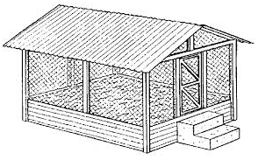
Diagram showing deep litter system.

Qn: State the importance of the following in a poultry house.
(a) Perches
- They control boredom in birds.
- They act as resting places for birds.
(b) A feeding trough
- It is where food for poultry is put.
(c) A conical drinking waterer
It is where chicken drink birds are kept in separate cages.
3. Battery / cage system.
This is a system where birds are kept in separate cages.
Qn: Write down at least two advantages of battery cage system.
- It is easy to collect eggs.
- Birds cannot easily be stolen.
- Birds cannot easily get lost.
- It is easy to control poultry vices.
- It is easy to identify sick birds.
Disadvantages of battery / cage system
(i) Birds do not get enough exercises.
(ii) Birds do not eat food of their choice.
(iii) It is expensive.
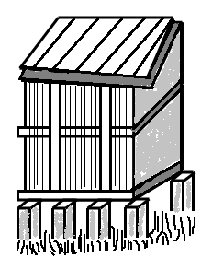
Diagram showing battery / cage system

4. Fold or pen system
This is a system where birds are kept in small houses called folds or pens.
Advantages of fold / pen system.
(i) Birds are protected from wild animals.
(ii) Birds cannot easily get lost.
(iii) Poultry feeds are not wasted.
(iv) It is cheap compared to battery / cage system.
(v) The farmer gets time to do other activities.
Disadvantages of fold / pen system.
(i) Few birds are kept.
(ii) Birds do not get enough exercise.
(iii) Birds do not eat food of their choice.
(v) It is tiresome to move the pens.
A diagram of a fold / pen system
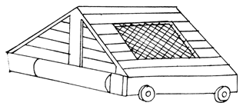

FEEDING CHICKEN
Qn: Give two importance of feeding chicken.
(i) To enable them grow.
(ii) To enable birds lay many eggs.
(iii) To enable birds form muscles.
Qn: Mention the type of feeds given to the following groups of birds.
(a) Chicks - Chick mash
(b) Layers - Layers mash
(c) Broilers - Broilers mash
(d) Layers between 4 – 16 weeks - Growers mash
(e) Broilers between 4 – 8 weeks - Growers mash
Qn: Name the items drawn below.
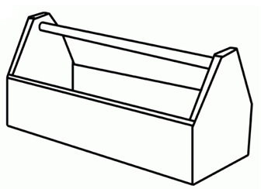 | 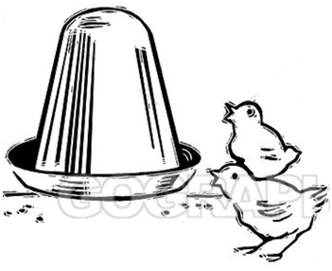
A feeding trough | Conical drinking waterer
Qn state the function of a feeding trough in a poultry house.
It is where food for poultry is put.
Qn: State the importance of a swivel bar on a feeding trough.
A swivel bar rolls to prevent birds from stepping in feeds.
Give the function of a water trough in a poultry house.
It is where birds drink water from.
Qn: Mention the minerals salts that make the bird’s egg shells and bone strong.
- Calcium
- Phosphorous
Qn: State the importance of calcium in poultry feeds.
Calcium enable birds lay hard shelled eggs.
Qn: Why do poultry farmers hang greens in a poultry house?
To enable birds to get exercises.
Qn: State the importance of greens to poultry.
Greens are sources of vitamins and minerals salts.
Practices done in poultry management.
(i) Regular cleaning of the house.
(ii) Culling
(iii) Debeaking
(iv) Vaccination
(v) Regular feeding
(vi) Egg collection
POULTRY PARASITES
Qn: What are parasites?
Parasites are living organisms that depend on other organisms for food.
Types of parasites.
(i) Ecto parasites/external parasites
(ii) Endo parasites/internal parasites
Ecto parasites
These are parasites that live outside on the body of a bird.
(i) Lice
(ii) Red mites
(iii) Depluming mites
(iv) Fleas
(b) Endo parasites
These are parasites that live inside the body of a bird.
Examples of endo parasites
(i) Tape worms
(ii) Hook worms
Qn: State any two ways of controlling parasites in poultry.
(i) Regular deworming
(ii) Regular deforming
(iii) Swab the body of a bird using paraffin.
(iv) Dust the body of a bird using chemicals.
(iv) Regular cleaning of the poultry house.
INCUBATION
Qn: What is incubation?
This is the providing of necessary conditions to a fertilized egg to enable it hatch into a chick.
Good conditions for eggs to hatch.
(i) Presence of warmth
(ii) Presence of moisture
(iii) Presence of oxygen
Qn: Write down any three factors that can make a fertilized egg fail to hatch.
(i) When the egg is too dirty.
(ii) When the egg has a soft shell.
(iii) When the egg has two yolks.
(iv) When the egg does not have air space.
(vi) Over heating during incubation
Qn: What is incubation period?
Is the time taken for an egg to hatch into a chick.
Qn: State the incubation period of each of the following birds.
(a) Hen - 21 days
(b) Pigeon - 14 days
(c) Geese - 30 days
(d) Turkey - 28 days
(e) Duck - 30 – 31 days
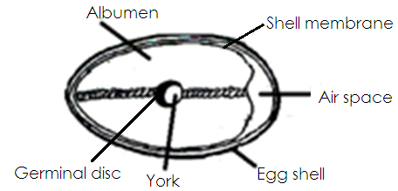
Structure showing parts of an egg.

Function of each part.
(a) Egg shell.
Protects the inside parts of the egg.
(b) Air space
- Provides oxygen to the embryo.
- It takes out carbon dioxide which is given off by the embryo.
(c) Chalaza/twisted albumen
- It holds the York and embryo in position.
- It carries food and water to the embryo.
- It carries oxygen from the air space to the embryo.
(d) Albumen / egg white
- It is a source of proteins to the embryo.
(e) Egg yolk
- It provides food for the embryo.
(f) Germinal disc
- Develops into a chick
- Qn: Why is the egg shell porous?
To allow gaseous exchange
TYPES OF INCUBATION
(i) Natural incubation
(ii) Artificial incubation
Natural incubation
- Is the type of incubation where a hen provides necessary conditions to eggs in order to hatch into chicks.
Qn. State the advantages of natural incubation
- It is cheap.
- It does not require skilled knowledge.
- Eggs are turned by the broody hen.
Disadvantages of natural incubation
- Few eggs are hatched.
- Eggs may not hatch in case the mother hen dies.
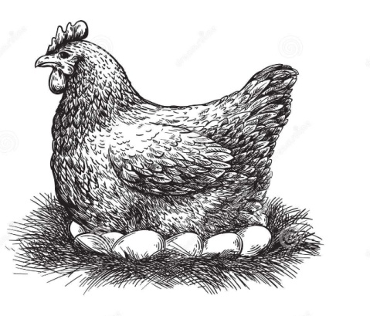
Diagram showing natural incubation

Artificial incubation
Is the type of incubation where an incubator provides necessary conditions to eggs until they hatch into chicks.
Advantages of artificial incubation
- Many eggs are hatched at once.
- An incubator can be used at any time.
Disadvantages of artificial incubation
- It is expensive.
- It requires skilled labour.
- It needs much care and attention.
Diagram showing an incubator
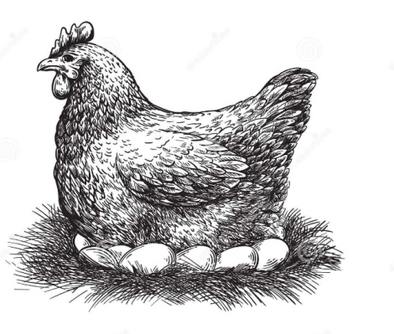 | 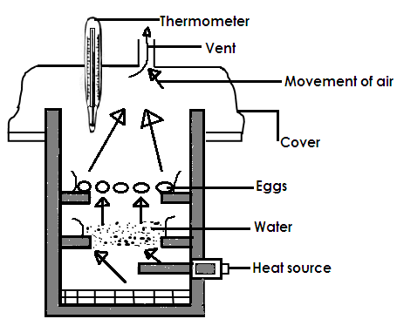
Natural incubation | An incubator
NATURAL BROODING
Qn: What is natural brooding?
Is the type of brooding where the mother hen provides care to its chicks.
Advantages of natural brooding
(i) It is cheap
(ii) It does not need a lot of care and attention.
(iii) A farmer gets time to do other activities.
(iv) Toe pecking is reduced.
Disadvantages of natural brooding
(i) Chicks may be eaten by wild animals.
(ii) Chicks can easily be stolen.
(iii) Chicks can easily get lost.
(iv) It gives little profit.
Qn: Mention any two things a broody hen provides to her chicks.
- Warmth
- Food
- Security
ARTIFICIAL BROODING
QnWhat is artificial brooding?
Is the type of brooding where chicks are kept in a special structure called a brooder.
Advantages of artificial brooding
- Many chicks are kept in one place.
- Chicks cannot easily be eaten by wild animals.
- Chicks cannot easily be stolen.
- Chicks cannot easily get lost.
- Chicks are protected from bad weather.
- It is easy to feed chicks in one place
Disadvantages of artificial brooding
- It is expensive
- Chicks can die in case heat is not enough.
- It needs a lot of care and attention
- Toe pecking among chicks is difficult to control.
Qn: Define a brooder.
A brooder is a special structure where chicks are reared.
Qn: State any two things provided to chicks in a brooder.

- Warmth
- Food
- Water
- Security

- Types of brooders
(a) Charcoal brooders
(b) Infrared lamp brooders
(c) Kerosene brooders
Qn: State any two sources of heat in a brooder.
- Charcoal stove
- Kerosene brooders.

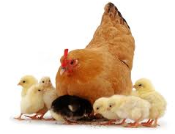 | 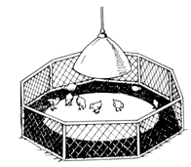
Natural brooding | A simple brooder

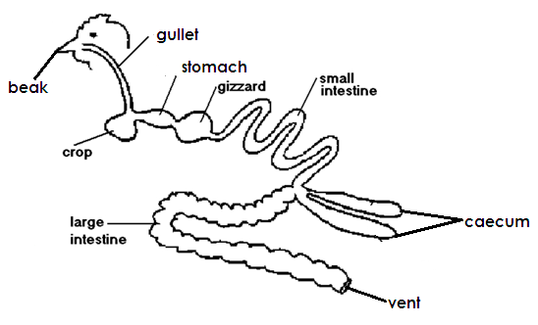
The digestive system of a domestic bird.

Uses of each part.
(a) The beak
For picking food.
(b) Gullet
It is a passage of food from mouth to the crop.
(c) Crop
It stores, softens and moistens food.
(d) Stomach
It is where food is mixed with digestive enzymes.
(e) Gizzard
It contains grit which crush food into small particles.
(f) Small intestines
It is where absorption of digested food takes place.
(g) Large intestines
It is where absorption of water takes place.
(h) Caeca
It stores waste materials before they are passed out.
(g) Large intestine
It is where absorption of water takes place.
(h) Caaca
It stores waste materials before they are passed.
(i) Vent
It is a passage of waste materials.
Qn: How is the nostril useful to a bird?
It is used for smelling.
Qn: State what happens to the food while in the crop of a bird.
- It is softened.
- It is moistened
Qn: Give the function of grit found in the gizzard of a bird.
For crushing food.
POULTRY DISEASES
Qn: Give any two causes of diseases in poultry.
- Poor feeding
- Poor hygiene in a poultry house.
- Overcrowding of birds
- Poor housing
- Feeding birds with contaminated food and water.
Examples of poultry diseases and their causes.
Disease | Cause
Coccidiosis  Black head  Fowl typhoid  Pneumonia  Fowl pox  New castle disease  Gumboro  Avian leucosis | Protozoa  Protozoa  bacteria  bacteria / virus  Virus  Virus  Virus  virus
Poultry diseases, their prevention and treatment
Disease | Signs and symptoms | Prevention and treatment
Pneumonia | - Coughing  - Mucus comes out of the nose  - Dullness  - Difficulty breathing | - Keep the house clean.  - Make the house well ventilated.  - Cull the sick birds
Coccidiosis | - Dropping wings  - Rough feathers  - Yellowish diarrhoae  - Droppings with blood  - Dropping wings. | - Keep the house clean.  - Cull the sick birds
Fowl typhoid | - Yellowish – green diarrhea  - Rough feathers  - Sleepy eyes  - Dullness | - Burn or bury dead birds.  - Cull the sick birds  - Vaccinate the birds.
New castle disease | - Mucus from mouth and nose.  - Coughing  - Lameness  - Sudden death of birds in large numbers. | - Keep the house clean.  - Vaccinate  - Kill and bury infected birds.
Fowl pox | - Discharge of liquids from eyes and nostrils.  - Tiny wounds on the comb, wattle, wings and mouth.  - Eyes get sleepy and stuck. | - Regular vaccination.  - Keep the house clean.  - Cull all sick birds.
Gumboro disease | - Dropping wings.  - Diarrhoea with blood stains.  - Rough feathers  - Birds peck their feet. | - Cull the sick birds.  - Vaccinate  - Burn or bury dead birds.

Qn: Write down any three ways of preventing and controlling disease in poultry.
(i) Keep the poultry house clean.
(ii) Regular vaccination
(iii) Put coccidiostats in poultry feeds.
(iv) Culling all sick birds
(v) Burn or burry dead birds.
(vi) Have a foot bath at the door of a poultry house.

Qn: List down any four effects of diseases and parasites on a poultry farm.
(i) They lead to stunted growth.
(ii) They reduce production
(iii) They reduce profits
(iv) They reduce income.
POULTRY VICES
Qn: What are poultry vices?
(i) Poultry vices are bad habits in poultry.
Qn: Write down any two causes of poultry vices.
(i) Hunger
(ii) Poor feeding
(iii) Overcrowding birds
(iv) Boredom
(v) Too much light in a poultry house.
(vi) Lack of calcium in poultry feeds.
(vii) Failure to collect eggs in time.
Examples of poultry vices
- Cannibalism
- Egg eating
- Feather pecking
- Toe pecking
CANNIBALISM
It is the act of a bird eating another bird.
Causes of cannibalism
- Prolapse
- Crowding in the poultry house.
- Lack of proteins in poultry feeds.
- Starving birds
Prevention of cannibalism
- Hanging enough green vegetables in the poultry house.
- Regular feeding of birds.
- Providing enough space for birds.
- Avoiding overstocking
EGG EATING
- It is the act of birds eating their own eggs.
Causes of egg eating.
- Hunger
- Boredom
- Too much light in the nesting area.
- Lack of enough calcium in their bodies.
- Failure by the farmer to collect eggs in time.
- Presence of broken eggs.
Control of egg eating
- De-beaking the birds
- Hanging green vegetables.
- Nesting places should be kept dark.
- Provide feeds which contain calcium.
- Collect eggs regularly.
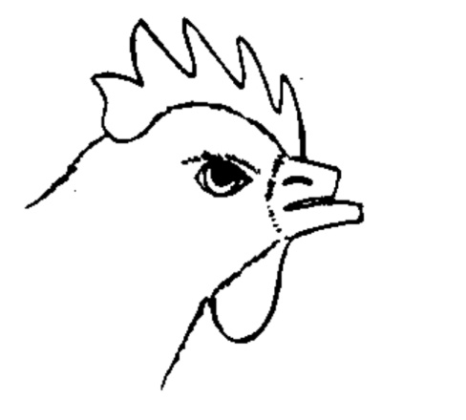
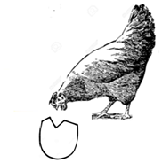
- Turn and change the litter regularly.
Egg eating vice | De-beaked bird

Qn. How does debeaking help to control egg eating?
It makes the beak of a bird blunt.
Qn. Mention any two devices used for debeaking.
- Hot knife
- Debeaking tool
- Sharp pair of scissors
FEATHER AND TOE PECKING
Feather pecking is where birds pluck off feathers from other birds.
Toe pecking is where birds peck the toes of other birds.
Control of feather and toe pecking.
- Avoiding crowding birds.
FARM RECORDS
Qn: What are farm records?
Farm records are written information about various activities carried out on a farm.
Qn: What is record keeping?
This is the keeping of information about various activities carried out on a farm.
Types of farm records
(i) Health records
(ii) Flock records
(iii) Feed records
(iv) Production records
(v) Sales and expenses records.
Importance of farm records.
(i) Farm records enable the farmer to plan for the farm.
(ii) Farm records enable the farmer to know the history of the farm.
(iii) Farm records help a farmer to know his income and expenditure.
(iv) Farm records help farmer to know if he is making profits or losses.
BEE KEEPING
Terms used
(a) Apiculture
Is the rearing of honey bees.
(b) An a piarist
Is a bee farmer
(c) An a piary
Is a place where we find many bee hives.
(d) A colony
Is a large group of bees in a hive.
(e) A swarm
A swarm is large group of bees moving in the same direction.
(f) Swarming
This is the movement of bees from one place to another.
(g) A nuptial / maiden / wedding flight
This is the flight during which a drone bee notes with a queen bee.
(h) Stocking the bee hive
Is the encouraging of bees to occupy an empty bee hive.
(i) Setting or setting a bee hive
Is the selecting of a suitable place in which to put a bee hive.
Social insects
These are insects which move, live and work together in large groups.
Qn: Write down any examples of social insects

- Honey bees
- Wasps
- Termites
- Red ants
- White ants
- Black ants

Qn: What are solitary insects?
These are insects that do not live, move and work together.
Qn: Identify any two examples of solitary insects.

- Houseflies
- Mosquitoes
- Moths
- Cockroaches
- Tsetse flies
- Bumble bees

Types of honey bees / castes of honey bees.

- Queen bee
- Drone bee
- Worker bees

QUEEN BEE
- It is the largest in a bee hive.
- It has a longer abdomen
- It is a female bee.
- It lays eggs.
- It has an ovipositor for laying eggs.
- It feeds of a special food called royal jelly.
- It develops from the fertilized eggs.
Qn: State the role of a queen bee in the hive.
- To lay eggs
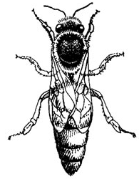
- Structure of a queen bee.

DRONE BEES
- They are the male bees in a hive.
- Drones drove from unfertilized eggs.
- Drones do not have a sting.
- They make a buzzing sound while flying.
Qn: State the role of s drone bee in a hive.
To fertilize the eggs of a queen bee.
Qn: Why does a drone bee die shortly after mating with the queen?
- The sexual organ breaks off during mating damaging the abdomen.
- The abdomen is damaged.

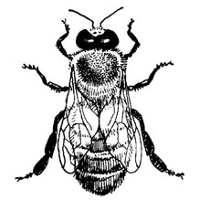
Structure of a drone bee.

WORKER BEES
- They are female sterile bees in a hive.
- They are smallest in the hive.
- They have pollen basket on their hind legs
- They develop from the fertilized eggs.
- They do not have ovipositor.
- They have a sting.
Duties of worker bee.
- They build and repair the hive.
- They collect pollen and propolis.
- They protect the hive.
- They feed the queen.
- They feed the grub.
- They defend the hive.
- They produce wax.
- They make honey.
Structure of a worker bee.
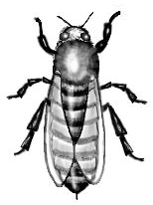

Qn: Why is a worker bee unable to lay eggs?
It does not have an ovipositor.
Qn: Why are worker bees called female sterile bees?
They do not lay eggs.
Qn. Why does a worker bee die after stinging a person?
- The loss of sting results in damaging of the bees abdomen.
- The abdomen is damaged.
Qn. How do worker bees control temperature in a hive?
By rapid flapping of their wings.
Qn. Name the food given to the queen bee by the worker bee.
- Royal jelly
Qn. Write down any two things collected by bees from the environment.
- Nectar
- Propolis
- Pollen
- Water
Qn. Why do worker bees collect water and nectar?
- For making honey.
Qn. State the use of propolis to bees?
- For repairing the hive.
- For smoothing the inside of the bee hive.
- Water proofs the hive.
Qn. Name the part of a worker bee that produces wax.
- Wax glands
Importance of bees to people.
- People get honey
- People get bee wax from bees.
- Bees pollinate flowers.
Importance of bees to plants.
- Bees help in pollination of plants.
- Bees keeping encourages people to preserve trees.
Products got from bees.
- Honey
- Bee wax
Qn. Give any two uses of honey.
- Honey is used as medicine.
- Honey is eaten as food.
- Honey is used to sweeten bread.
- Honey is used to sweeten tea.
- Honey is a source of income when sold.
Qn. What food value is obtained from eating honey?
- Carbohydrates.
Uses of bee wax
(i) Bee wax is used to make candle wax.
(ii) Bee wax is used to make shoe polish.
(iii) Bee wax is used to make floor polish.
(iv) Bee wax is used to make cosmetics.
(v) Bee wax is used to make ice cream.
(vi) Bee wax is used to make crayons.
Products obtained from bee wax

- Candle wax
- Shoe polish
- Floor polish
- Cosmetics

LIFE CYCLE OF A HONEY BEE

Qn. How do bees reproduce?
- By laying eggs.
Qn. Which type of life cycle do honey bees undergo?
- Complete life cycle.
Qn. Name the stages of development a honey bee undergo.
- Eggs
- Larva
- Pupa
- Adult
Qn. What name is given to the larva stage of a honey bee?
- Grub
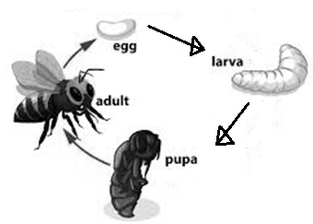
Illustration showing the life cycle of a honey bee.

Qn. Name the organ where the queen bee stores sperms.
- Sperm sac / spermatheca
SWARMING
Swarming is the movement of bees from one place to another looking a new hive.
Causes of swarming in bees.
- Direct sunlight to the hive.
- Direct smoke into the hive.
- Too much noise around the bee hive.
- Bad smell in the bee hive.
- When the queen bee hive.
- When another queen is hatched.
- Leaking bee hive.
- Shortage of flowers and water in a place.
- Overcrowding of bees in a hive.
- Attacks from their enemies.
- Bad smell around the hive.
ENEMIES OF BEES
- Honey badgers
- Safari ants
- Wax moths
- Termites
- Hive beetles
Ways of preventing and controlling bee enemies
(i) Smearing oil on poles of bee hives.
(ii) Spraying using insecticides.
(iii) Spraying using insecticides.
(iv) Hang bee hives between two poles.
(v) Keep grass around bee hives short.
Diseases of bees
- Stone brood
- American foul brood
- European foul brood.
TYPES OF BEESHIVES
(a) Traditional bee hives.
(b) Modern bee hive.
Traditional bee hives
A hive is a home of bees.
Examples of traditional bee hives
(i) Kigezi bee hive
(ii) Dugout log hive.
(iii) Tin hive
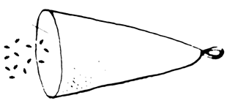 | 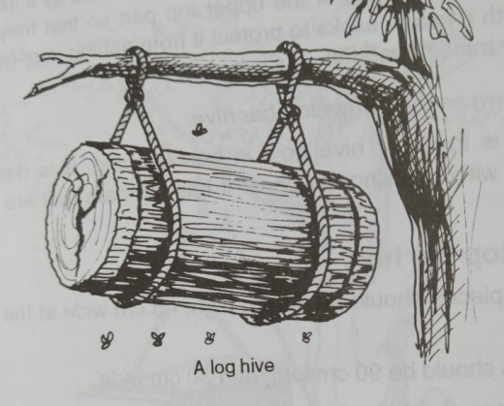
Kigezi hive | Dug out lo hive
Advantages of traditional bee hives.
(i) They are cheap and easy to make.
(ii) The colony is not disturbed by the bee keeper.
Disadvantages of a traditional hive.
(i) The colony cannot be inspired.
(ii) The hive is damaged in the process of harvesting honey.
(iii) The honey harvested is not always clean.
(iv) The hive does not last for long.
(v) It is not easily to inspect the colony.
MODERN BEE HIVES
Examples of modern bee hives
(a) Box hive
(b) Top bar hive
Parts of a modern bee hive
(a) Queen excluder
It prevents the queen from going to the honey chamber.
(b) The holes
To allow worker bees pass through
(c) Honey chamber
It is where honey is stored.
(d) Brood chamber
It is where the queen lays her eggs.
Qn. Why is the excluder made of tiny holes?
To allow only the worker bees which have to prepare honey.
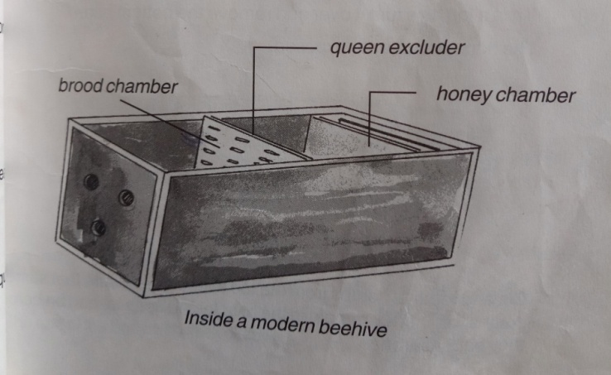
Inside a modern bee hive.

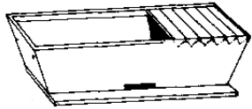
A diagram of a top bar hive

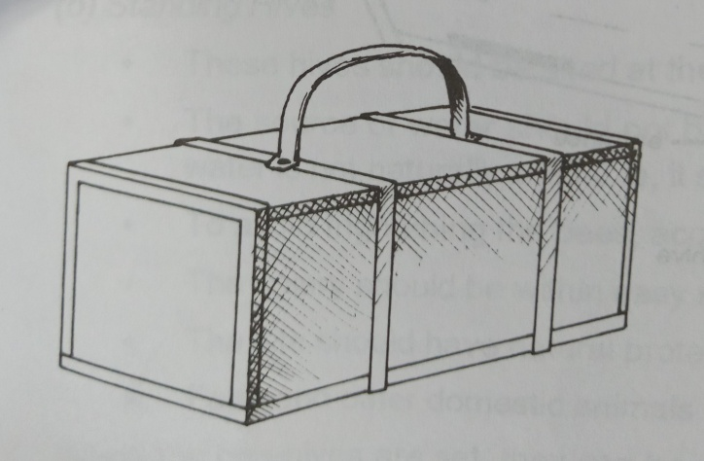
Box hive

Advantages of a modern hive
- Clean honey is harvested.
- It is easy to inspect the colony.
- A modern bee hive lasts for a long time.
- A hive is not destroyed during honey harvested.
- The colony develops undisturbed.
Disadvantages of a modern hive.
- It is expensive to make.
- The colony is disturbed by the bee keeper.
Sitting the hive
This is the selection of a suitable place in which to put bee hives.
Factors to consider when selecting a suitable place in which to put bee hives.
(i) The place should be free from noise.
(ii) The place should be away from the main road.
(iii) The place should be near flowering plants.
(iv) The place should be near a water source.
(v) The place should be far from people and animals.
(vi) The place should be sheltered from direct sunlight.
STOCKING THE HIVE
- Is encouraging bees to occupy an empty hive.
Qn. Give any two ways of stocking a bee hive.
(i) By smearing bee wax in a hive.
(ii) By using a swarm catcher or catcher box.
(iv) By using a swarm catching net.
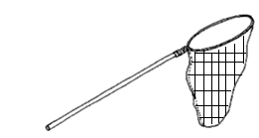
A swarm catching net.

HARVESTING HONEY
Qn. Equipments needed by a honey harvester.
- Bucket - bee veil - Gumboot - gloves - smoker
- knife
Harvesting honey is removing honey combs from the bee hive.
Qn. State the function of each of the following equipment when harvesting honey.
(a) Bucket
It is where harvested honey is put.
(b) Knife
For cutting honey combs.
(c) Overall
It protects the body of the honey harvester from bee stings.
(d) Bee veil
Protects the head of the honey harvester from bee stings.
(e) Gloves
Protects the hands of the honey harvester from bee stings.
(f) Gum boots
Protect the feet of the honey harvester from bee stings.
(g) Smoker
Produces smoke that calms bees.
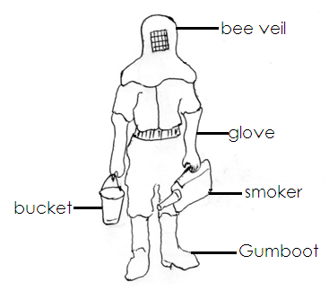
Diagram showing a honey harvester

Methods of harvesting honey
(a) Traditional method.
(b) Modern method
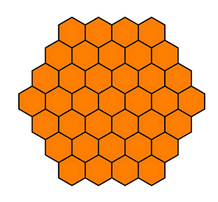
Honey combs

Qn. Why is harvesting of honey best done in the evening?
All bees are in the hive and in active.
EXTRACTION OF HONEY
Extracting honey means removing honey from the honey combs.
Methods of extracting honey
(a) Floating the wax method.
(b) Pressing the honey method.
(c) Centrifuging method
Floating the wax method
- Break the honey combs and put them in a large container.
- Put some water in a big sauce pan and place it on fire.
- Place the container with honey combs on a big saucepan with boiling water.
- The wax and honey will melt and wax will float on honey.
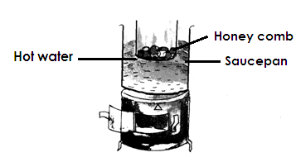
An illustration showing floating wax.

Pressing the honey method.
(i) The honey comb is placed on a piece of cloth.
(ii) Honey combs are then wrapped in a clean piece of cloth.
(iii)Dip the wrapped honey combs in warm water.
(iv)Squeeze the honey combs wrapped in a cloth to make honey come out.
Illustration showing steps for pressing the honey method.
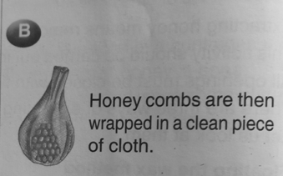
Step 1 Step II
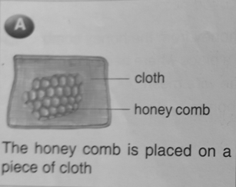

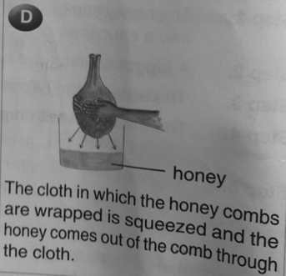
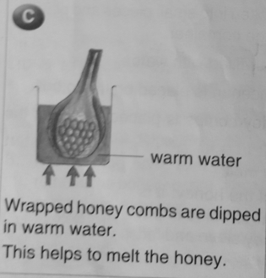
Step III Step IV

Centrifuging method / spinning method
This is where a mechanic is used to extract honey from the honey combs.
Qn. What name is given to a machine used to extract honey from the honey combs?
- Centrifugal honey extractor.
Steps:
- Remove the wax that seals the comb and put the honey comb in the machine.
- The machine spins the honey combs round at a very high speed forcing honey to filter out.
- The honey then settles at the bottom of the machine.
- Boil the honey and store it a clean container.
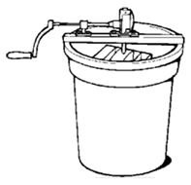
A centrifugal honey extractor / machine.

Qn. State the importance of warm water during floating the honey method.
- To make wax and honey melt.
Qn. Why can’t honey go bad?
- Honey has a lot of sugars and less water.
TOPIC TWO
MEASUREMENTS
Qn. What is a measurement?
Is the process of finding how long, short, small, big, heavy or light an object is.
Examples of measurements quantities.
- Mass - capacity - Time - volume - Temperature
- Density - speed - weight - Distance

Measuring mass
Qn. What is mass?
Mass is the amount of matter in an object.
Qn. State the basic unit for measuring mass.
- Grammes
Qn. State the S.1 unit for measuring mass.
- Kilogrammes
Qn. Identify any two instruments used to measure mass.
- Beam balance
- Clock balance
- Lever balance
Illustration showing common weighing balance.
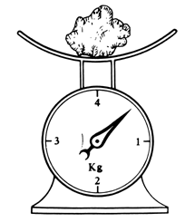
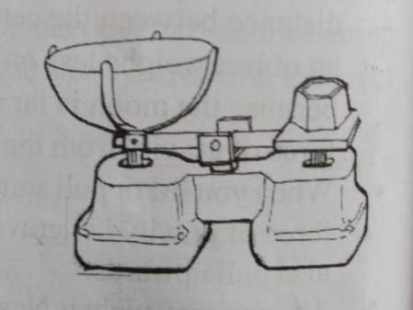
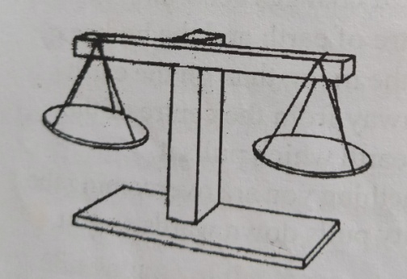
Beam balance | Clock balance | Lever balance
Measuring weight
Qn. What is weight?
Weight is a measure of how much force of gravity is acting on an object.
Qn. State the units in which weight is measured.
- Newton
Qn. Name the instrument used to measure weight.
- Spring balances
Illustration of spring balances

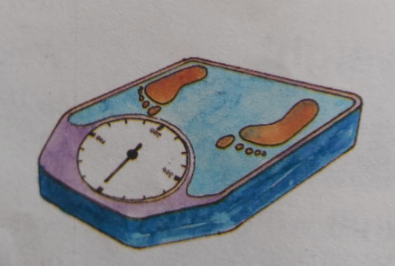

Qn. What is gravity?
- Gravity is a force of attraction that pulls things down towards the centre of the earth.
Qn. Give a reason why objects thrown up come down on earth.
- Due to gravity force.
Qn. Name the force that objects thrown up come down on earth.
- Gravity force.
Difference between weight and mass.
(i) Mass is measured in grammes while weight is measured in Newtons.
(ii) Mass is measured using a beam balance while weight is measured using a spring balance.
(iii) Mass of an object does not change wherever it is measured while weight changes when measured in different places.
(iv) Mass is the amount of matter is a body while weight is a measure of how much force of gravity is acting on an object.
Measuring capacity
Qn. What is capacity?
- Capacity is the amount of liquid any container can hold.
Qn. State the basic unit for measuring capacity.
- Litre
Qn. Mention any two examples of liquids people buy in litres.
- Paraffin - cooking oil - water - milk
Qn. Name the instrument used to measure capacity of liquids.
- Hydrometer
Measuring volume
Qn. What is volume?
- Volume is the space occupied by an object.
Qn. State the units in which volume is measured.
- Cubic units
Finding capacity of a container.
To find the capacity of a container, first find its volume.
Example 1
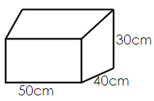
Find the capacity of the container below.

To find volume we multiply length with the width and weight.
Volume = Length x Width x Height
= 50cm x 40cm x 30cm
= 6000cm³
To find the capacity of the container, we change the volume to litres.
1litre = 1000cm3
= 6000cm3
= 1000cm3
= 6litres.
Activity:
Find the capacity of the container below.
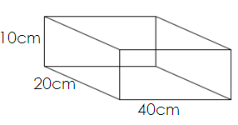

SHAPED OBJECTS
There are two groups of shaped objects namely;
(a) Regular objects
(b) Irregular objects
Regular objects
These are objects with well defined shapes.
Examples of irregular objects.
- A rectangular block
- A triangular prism
- A cylindrical tank
- A circular clock
- Cuboids
- Cube
- Chalk box
Finding the volume of irregular objects
To find the volume of a regular object, we multiply area of the base by the height.
Volume = Length x Width x Height
V = L x W x H
Example I
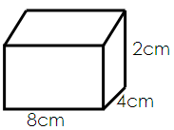
Find the volume of the brick below.

Volume = Length x Width x Height
= 8cm x 4cm x 2cm
= or 64cc
Activity:
Find the volume of the figures below.
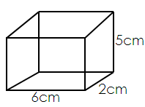
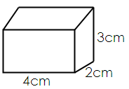
(a) (b)

Irregular objects
Irregular objects are objects that do not have a well defined shape.
Qn. Mention any two examples of irregular objects.

- Stones
- Broken glasses
- Sweet potatoes
- Irish potatoes
- Mango

Measuring volume of irregular objects.
- Displacement method.
Qn. Name the method used to find the volume of irregular objects.
- Displacement method.
Qn. Write down any two equipments use to find the volume of irregular objects.
(i) Overflow can / Eureka can / Displacement can
(ii) Measuring cylinder
(iii) String

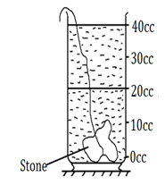 | 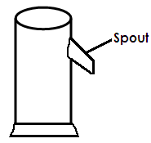
measuring cylinder | Eureka can

Measuring cylinder - Measuring the volume of an irregular object.
String - to lower the irregular object gently in water.
(a)Measurement the volume of an irregular object using a measuring cylinder.
(i) An irregular object was immersed in water as shown below.

(a) Find the volume of the irregular object.
Volume = second level - first level
= 25cc - 10cc
= 15cc

2. The experiment below was carried out by the P.5 class of ST Anthony primary school.
Study it carefully and use to answer the question that follows
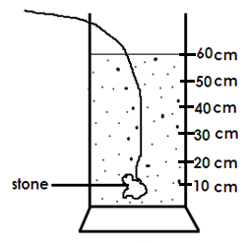
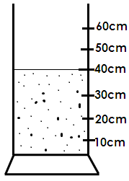

After lowering the stone Before lowering the stone

Volume = 2nd level - 1st level
= 60cm - 40cm
= 20cm³ or 20cc

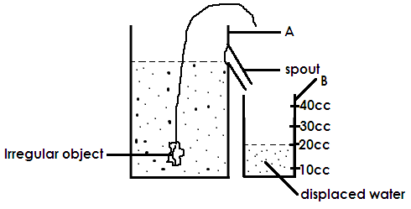
(b) Measuring the volume of an irregular object using a Eureka can and a measuring cylinder.

(i) Calculate the volume of the irregular object.
20cc
(ii) Give a reason for your answer above.
The volume of the water displaced is equal to the volume of the irregular object.
(iii) Name the container marked A and B.
A - Overflow can
B - Measuring cylinder
(iv) Why is the above method used when find the volume of an object like a stone?
A stone has no definite shape.
(v) When is the above method used?
When measuring the volume of an irregular object.
(vi) State the function of the measuring cylinder in the above experiment.
To measure the volume of displaced water.
DENSITY
Qn.What is density?
- Density is mass per unit volume.
Qn. State the units in which density is measured.
- Grammes per cubic centimeters or milliliters (gm / cc or gm /)
Finding density

Density = Mass
Volume
D = M
V
Example I
An object has mass 24gm and volume 8cc. Find its density.
D = M
V
= 24gm
8cc
= 3gm /cc
Activity
1. Find the mass of an irregular object with density 4gm / cc and volume 10cc.
2. Find the volume of the irregular object if its mass is 50gm and the density is 5gm / cc.
3. Calculate the density of the irregular object if its mass is 40gm and the volume is 20cc.
4. A brick has mass of 72gm and density of 6gm/cc. Calculate its volume.
5. Find the mass of an object whose density is 3gm / cc and volume 8 cc.
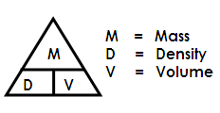
NOTE: You can use this triangle to remember the formulae

M = D x V
D = M
V
V = M
D

Behavior of objects with water.
Qn. What happens to a leaf when put in water?
- It floats on water
Qn. What happens to a coin of sh. 500 when put in water?
- It sinks in water
Floating and sinking objects
Qn. What are floating objects?
- These are objects which remain on top of water when put in it.
Qn. Why do some objects float on water?
- Some objects have less density than water.
Examples of floating objects.

- Leaf
- A feather
- A paper
- Dry wood

Qn. Give a reason why a leaf floats on water.
- The density of a leaf is less than that of water.
Qn. What are sinking objects?
- These are objects which settle at the bottom of water when put in it
Qn. Why do some objects sink in water?
- Some objects have more density than water.
Examples of sinking objects.
(i) A stone
(ii) A coin
(iii) Nail
(iv) Sand
Qn. Give a reason why a stone sinks in water.
The density of a stone is more than that of water.
Qn. Name the force that makes objects weigh less when put in water.
Up thrust force / buoyancy force
Qn. What is buoyancy force?
Is the force that makes objects weigh less when put in water.
Qn. Mention the instrument used to measure the density of liquids.
Hydrometer.
TOPIC 3
IMMUNITY AND IMMUNISATION
Qn. What is immunity?
Immunity is the ability of the body to fight against disease causing germs.
Importance of immunity.
Immunity enables the body to resist against diseases.
Qn. What is immunization?
Immunisation is the introduction of vaccines into the body.
Qn. What are vaccines?
Vaccines are special drugs that are introduced into the body to make it produce antibodies against certain disease.
Types of vaccines
(i) Toxoid vaccines e.g. tetanus toxoid.
(ii) Attenuated living vaccines e.g. BCG vaccine, measles, vaccine, Rubella vaccine, OPV vaccine
(iii) Killed vaccines e.g. IPV vaccine, rabies vaccine, cholera vaccine, influenza vaccine, hepatitis A vaccine
Importance of vaccines
Vaccines enable the body to produce antibodies against certain disease.
Types of immunity
(a) Natural immunity
(b) Acquired artificial immunity
Qn. What is natural immunity?
This is the type of immunity where the body builds its own antibodies.
Qn. Give three ways how a baby can acquire natural immunity.
(i) Through breast feeding
(ii) Recovering from an illness
(iii) From a pregnant woman to her unborn child.
Qn. Mention two diseases whose immunity can be built after recovering from it.
- Measles
- Mumps
Qn. What is artificial immunity?
Is the type of immunity got through immunization.
Qn. State one way how the body can acquire artificial immunity.
Through immunization
Importance of immunization.
(i) It boosts the immunity of the body.
(ii) Immunisation enables that body to produce antibodies.
(iii) Immunisation protects the body against childhood killer disease.
(iv) Immunisation reduces infant mortality rate.
Qn. State any two methods how vaccines are introduced into the body.
- Oral method
- Injection method
CHILDHOOD OR INFANT KILLER DISEASES
Qn. Identify any four examples of immunisable childhood diseases.

- Polio
- Tuberculosis
- Diphtheria
- Hepatitis B
- Tetanus
- Whooping cough (pertussis)
- Measles
- Haemophilus influenzaetypeb

POLIOMYELITIS (POLIO)
Qn. What causes polio?
Viruses
Qn. How is polio spread?
- Through drinking water contaminated with polio viruses.
- By house flies
Signs and symptoms of polio

- Weakness of bones and muscles
- Lameness
- Paralysis of limbs
- Fever

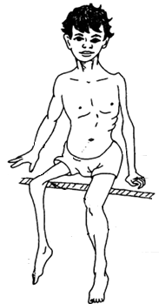
Diagram showing a child with polio.

Prevention of polio
- Drinking boiled water
- Proper disposal of human faeces.
- Immunizing all children at birth using polio vaccine.
Qn. How is the polio vaccine given to babies?
Orally or drop in the mouth.
TUBERCULOSIS
Qn. What causes tuberculosis?
Bacteria
Qn. How is tuberculosis spread?
Through air
Qn. What name is given to diseases which spread through air?
Air borne disease.
Signs and symptoms of tuberculosis
(i) Chronic cough
(ii) Loss of weight
(iii) A lot of sweating at night
(iv) Loss of appetite
(v) Pain in the chest.
Prevention of tuberculosis
- Immunizing children with the BCG vaccine
- Always drink boiled milk
- Treatment is isolation
DIPHTHERIA
- It is caused by bacteria
- It spreads through air.
Signs and symptoms of diphtheria

- Swollen neck
- Sore throat
- Fever
- Difficulty in breathing
- Headache

Prevention of diphtheria
Immunizing children with the DPT vaccine.
(PERTUSSIS (WHOOPING COUGH)
- It is caused by bacteria
- It spreads through air
Signs and symptom of pertussis

- Runny nose
- Severe coughing
- Loss of weight
- Wheezing sound while coughing

TETANUS
It is caused by bacteria.
Qn. How is tetanus spread?
- Through dirty wounds and cuts.
- At birth cutting the umbilical cord with a contaminated object.
Signs and symptoms of tetanus
- Stiff muscle all over the body.
- Spasm when touched
- The baby stops suckling
- Fever and headache
Prevention of tetanus
- Immunising children with DPT vaccine.
- Pregnant given (TT) Tetanus Texoid vaccine.
- Wounds and cuts should always be dressed and kept clean.
- Use clean objects to cut the umbilical cord of a baby.
Qn. Why are pregnant women and girls of child bearing age given Tetanus toxoid vaccine?
- To protect them and their unborn babies against tetanus.
Qn. Give a reason why DPT vaccine is called a triple vaccine?
It is given against three immunisable childhood diseases.
Qn. Why is polio vaccine given to babies at birth?
Babies are not born with immunity against polio.
Qn. Name the vaccine given to a baby once in life time.
BCG vaccine
HEPATITIS B
It is caused by virus.
Qn. Name the body organ which is affected by hepatitis B.
Liver
Qn. How is hepatitis B spread?
- Through sharing sharp skin piercing objects.
- Through blood transfusion with contaminated blood.
- Through unprotected sexual intercourse with an infected person.
Signs and symptoms of hepatitis B

- Dark urine
- Greyish stool
- Yellowish eyes
- Vomiting
- Tiredness
- Fever

Prevention of hepatitis B
- Immunise all chicken with Hepatitis vaccine.
- Abstain from sex.
- Do not share sharp skin piercing objects.
HAEMOPHILUS INFLUENZAE TYPE B
- It is caused bacteria
- It is spread through air.
Signs and symptoms of haemophilus influenza b
- Immunisation of children with Hib vaccine.
- Treating the infected person in isolation.
MEASLES
- It is caused by virus
- It spreads through air.
Signs and symptoms of measles

- Skin rash all over the body.
- Sore mouth
- Red eyes
- Running nose.

Prevention of measles
- Immunize children using measles vaccine.
- Isolate infected children
Qn. Why is measles vaccine given to babies at nine months?
The babies are born with immunity against measles which weakens at 9 months.
Qn. What is a pentavalent vaccine?
Is a vaccine with five antigens.
Qn. Mention any two examples of a pentavalent vaccine.
- DPT vaccine
- Hep B vaccine
- Hib vaccine
Qn. Why is DPT + Hep B + Hib vaccine called a pentavalent vaccine?
It is administered against five diseases.
A table showing the child’s immunization schedule.
DISEASE | VACCINE | AGE | METHOD OF ADMINISTRATION
Tuberculosis | BCG vaccine | At birth | by injection on the right upper arm.
Polio | Polio vaccine | At birth  6 weeks  10 weeks  14 weeks | Orally  (drops in the mouth)
- Diphtheria  - Pertussis  - Tetanus  - Hepatitis B  - Haemophilus  - influenza b | DPT – Hep B + Hib | 6 weeks  10 weeks  14 weeks | By injection on the left upper arm.
Measles | Measles vaccine | 9 months | injection on the left upper arm.

Qn. Name the vaccines given to babies at birth.
- BCG vaccine
- Polio vaccine
Qn. Mention two diseases whose vaccine are administered to babies at birth.
- Polio
- Tuberculosis

An illustration showing the immunization sites and vaccine.
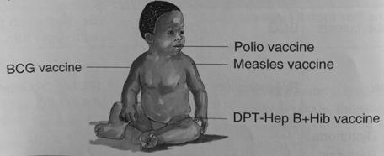

Other immunisable diseases and their vaccines.
- Cholera - oral cholera vaccine
- Meningitis - Meningococal vaccine
- Yellow fever - Yellow fever vaccine
- Rabies - Rabies vaccine
- Rubella / German measles - Rubella vaccine
- Pneumonia - Pneumoccocal conjugate vaccine (PCV)
- Diarrhoea - Rotavirus vaccine
- Cancer of the cervix - HPV vaccine
CHILD HEALTH CARD
Is a card which contains the child’s growth and health records.
Qn. Write down at least four important information found on a child health card.

- Child’s name
- Child’s sex
- Child’s date of birth
- Child’s birth order
- Child’s weight at birth
- Mother’s occupation
- Father’s name

Qn. State the importance of a child health card to a parent.
- It helps the parent to monitor the growth of the child.
- It helps the parent to know the date of the next immunization.
Qn. How is a child health card important to a health worker?
It helps the health worker to know which dose of immunization was given and what is remaining.
Qn. How can a P.5 teacher tell that a child was immunized against tuberculosis without using a child health card?
Checking for the immunization scar on the right upper arm.
Qn. How is a child health card useful to a school?
It helps the school management to know if the child was immunized or not.
Qn. How can a P.5 pupil participate in the immunization programme?
- Reminding the parent of the dates of immunization.
- Taking the siblings for immunization.
- Singing songs that interest people about immunization.
- Acting plays about immunization.
- Organizing the immunization centres.
Qn. State one way a family can participate in the immunization programmes.
Taking all children in a family for immunization.
Qn. State one way a community can participate in the immunization programme.
Setting up immunization centres.
Qn. How can the government of Uganda promote immunization programme?
- Providing vaccines
- Building health centres
- Training health workers
Qn. Why is immunization free in Uganda?
To enable all parents take their children for immunization.
Qn. Write the following in full.
- UNEPI - Uganda National Expanded Programme on Immunisation.
- NIDs - National Immunisation Days
Qn. Suggest the roles played by UNEPI
- To supply vaccines to different health centres.
- To teach people the importance of immunization.
- Training health workers on how to carry out immunization.
Qn. Name the special refrigerator in which vaccines are stored.
Vaccine carrier
Qn. Why are vaccines stored cool conditions.
To prevent them from going bad easily.
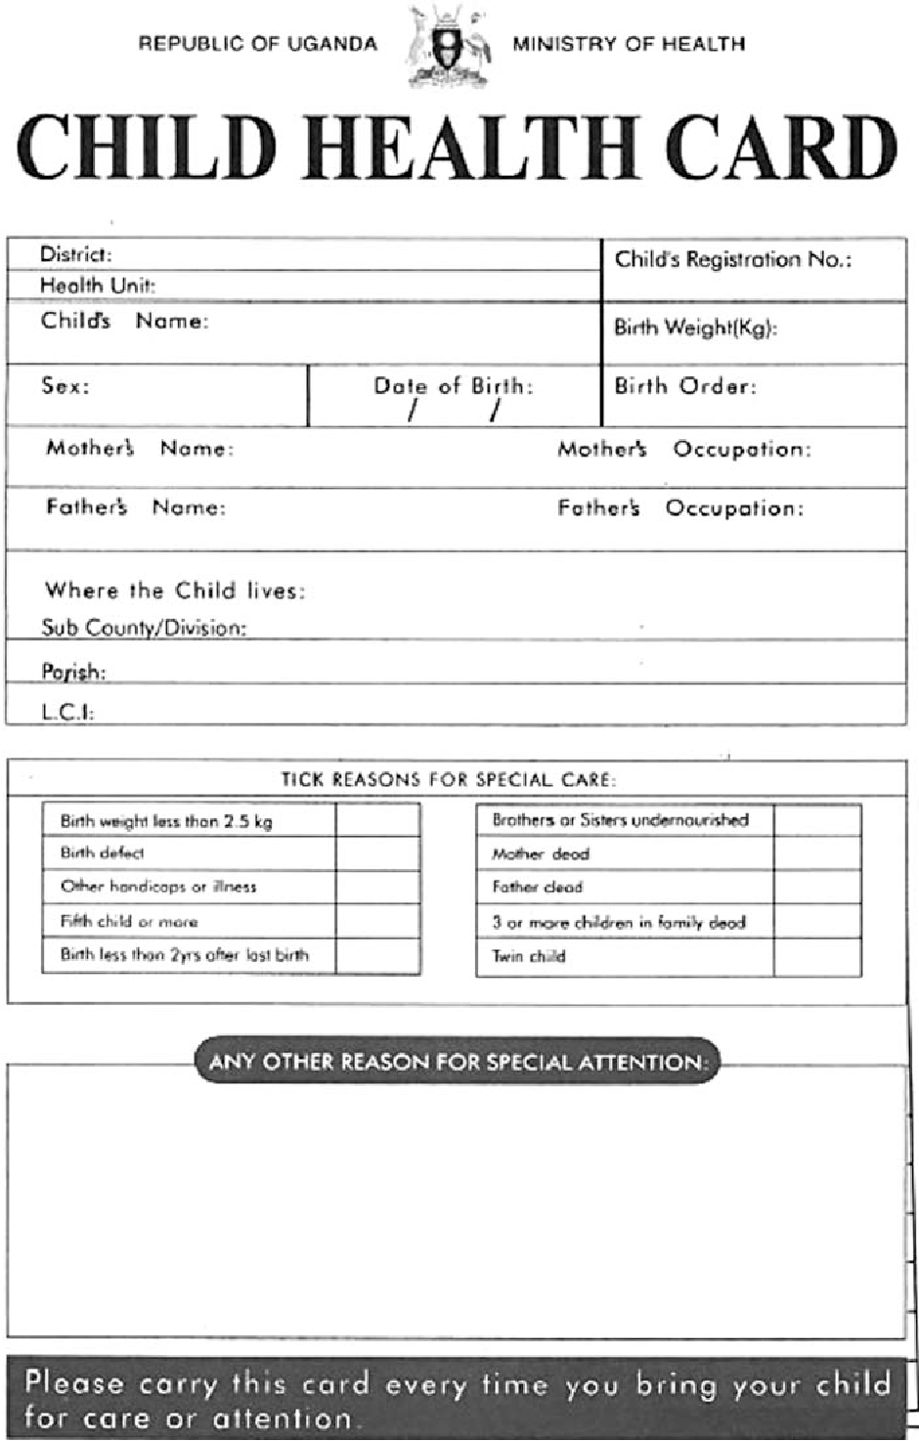
A child health card

TOPIC FOUR
THE DIGESTIVE SYSTEM
Qn. What is the digestive system?
Is a group of organs which help to break down food making it usable by the body.
Qn. What is digestion?
Is the process by which food is broken down into smaller soluble particles that can be absorbed into the blood stream.
Qn. Who is the alimentary canal?
Is a muscular tube running from the mouth to the anus.
Qn. Mention the parts that make up the alimentary canal.
- Mouth
- Gullet
- Stomach
- Small intestine
- Large intestine
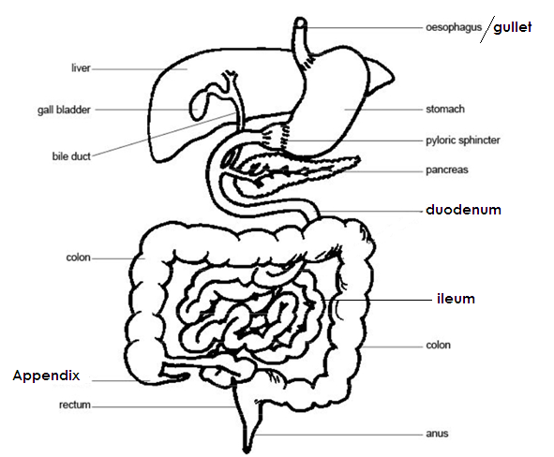
Diagram showing the digestive system.

Qn. Write down the types of digestion.
(i) Chemical digestion
(ii) Mechanical digestion
Qn. What is mechanical digestion?
Is the type digestion carried out by the action of the teeth in the mouth.
Qn. What chemical digestion?
Is the type of digestion carried out by enzymes.
ENZYMES
Qn. What are enzymes?
Enzymes are chemical substances that speed up the digestion of food.
Qn. State any four characteristics of enzymes.
- They are destroyed by heat.
- They are proteins in nature.
- They always form the same end product.
- They act on one kind of food.
Digestion in the mouth
Qn. Where does digestion of food in man begin?
In the mouth
Qn. Where in man does digestion of food end?
In the ileum
Qn. State the role of the following in the mouth during digestion.
- Teeth - To break food into small particles.
- Tongue - To roll food into a bolus.
- Salivary glands -To produce saliva
- Saliva -Softens down food
Qn. Name one enzyme found in saliva.
Salivary amylase (ptyalin)
Qn. Under what condition does salivary amylase work?
Alkaline condition
Qn. State the use of salivary amylase in the mouth.
Digests cooked starch in the mouth
Qn. What is peristalsis?
- Peristalsis is the wave-like movement of food through the alimentary canal.
- Movement of substances through tubular organ.
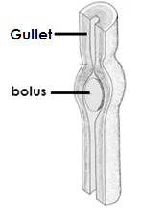
Diagram showing peristalsis

DIGESTION IN THE STOMACH
The stomach stores food for a short period of time.
Qn. Name the gland found in the stomach.
Gastric gland
Qn. State the function of the gastric gland.
To produce gastric juice.
Qn. Give the function of the gullet.
Passes food from the mouth to the stomach.
Qn. Mention the two enzymes contained in gastric juice.
- Pepsin
- Rennin
Qn. State the function of each of the following enzymes in the stomach.
- Pepsin - Digests proteins
- Rennin - Clots milk protein in babies.
Qn. Name the enzymes found in the stomach of babies.
Rennin
Qn. Name the acid produces by the stomach walls.
Hydrochloric acid
Qn. State the function of hydrochloric acid found in the stomach.
- To kill germs that comes along with food.
- To provide favourable conditions for enzymes in the stomach to act upon food.
Qn. Under what condition do pepsin and Rennin work?
Acidic condition
Qn. What is churning?
Is the process by which food is mixed with digestive juices in the stomach.
Qn. What name is given to the food which has been churned in the stomach.
Chyme
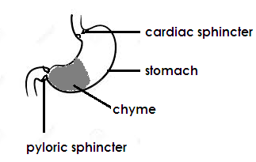
The stomach

Qn. State the function of each of the following sphincter muscle.
(a) Cardiac sphincter muscles
- To allow little food from the gullet to the stomach at a time.
(b) Pyloric sphincter muscle
- To allow a little chyme to the duodenum at a time.
Qn. Mention any two substances that are absorbed in the stomach.
- Alcohol
- Common salt
- Simple sugars
- Drugs
Digestion in the duodenum
Qn. Write down three enzymes found in the duodenum.
- Lipase
- Amylase
- Trypsin
Qn. State the function of the pancreas.
- To produce pancreatic juice.
- To produce insulin hormone
Qn. State the function of the following pancreatic enzymes.
(i) Lipase - It changes fats into fatty acids and glycerol.
(ii) Amylase - It changes uncooked starch into maltose.
(iii) Trypsin - Changes peptides into amino acids.
Qn. State the functions of the liver.
- It produces bile juice
- Stores important vitamins
- Stores important mineral salts.
- To control blood sugars
- The liver act as a detoxicating agent.
Qn. State the function of bile juice.
It breaks fats / emulsifies fats.
Qn. Give the function of the gall bladder.
It stores bile juice.
Digestion in the ileum
Digestion of food ends in the ileum.
Qn. Write down three enzymes found in the ileum.
- Lactose - Peptidase - Galactase - Erepsin - Maltase
- Sucrase
Qn. Identify the importance process that takes place in the ileum.
Absorption of digested food.
Qn. State two ways how the ileum is adapted to its function.
- It has the villi
- It is fairly long and coiled.
Qn. Name the finger like structure that helps in the absorption of food in the ileum.
Villi
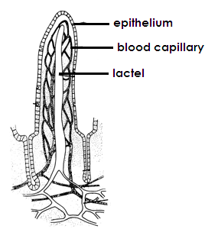
Structure of the villus

Qn. How are the villi adapted to their function?
- They are thick walled.
- The villi are surrounded by a great network of blood capillaries.
Qn. Mention two parts that make up the small intestines.
- Duodenum
- Ileum
Large intestines
Qn. Outline any three parts that make up the large intestines.
- Colon
- Rectum
- Anus
Qn. State one important process that takes place in the large intestines.
Absorption of water.
Qn. Give a reason why digestion of food cannot take place in the colon.
There is no enzyme in the colon to digest food
Qn. Why can’t absorption of digested food take place in the colon?
There is no villi in the colon
Qn. State the function of the appendix.
Stores undigested materials like stones
Qn. What is absorption?
Is the process by which digested food is taken into the blood stream.
Qn. By what process is digested food absorbed into the blood stream in the ileum?
Diffusion
Qn. Give the function of the rectum.
Stores faeces before they are passed out.
Qn. Mention the end products of digestion of each of the following food values.
(a) Proteins - Amino acids
(b) Carbohydrates - Glucose
(c) Fats - fatty acids and glycerol
Qn. Give a reason why vitamins and mineral salts are not digested.
Vitamins and mineral salts are soluble.
Qn. Name one blood vessel that transports blood rich in digested food from the ileum to the liver.
Hepatic portal vein
Diseases of the digestive system
- Cholera - Diarrhoea - Peptic ulcers - Typhoid
- Hepatitis B - Dysentery - Appendicitis
Disorder of the digestive system
- Vomiting - Constipation - Heart burn
- Intestinal obstruction - Indigestion
Qn. State any two cause of constipation
- Lack of enough water
- Lack of roughages
Qn. State two ways of preventing constipation.
- Eat fruits and vegetables regularly.
- Drink water or juice after eating food.
- Eat food rich in roughages
Qn. Which disorder of the digestive system in Dube who eats hurriedly without chewing food properly likely to face?
Indigestion
Qn. State any two ways a P.5 pupil can avoid indigestion.
- Do not eat too much.
- Chew food properly.
- Drink water after eating food.
Ways of preventing diseases of the digestive system.
- Drinking boiled water
- Washing hands before handling food.
- Washing hands after visiting a latrine or toilet.
- Maintaining proper sanitation.
Ways of keeping the digestive system in good health working conditions.
- Maintaining good eating habits.
- Eat a balanced diet.
- Doing physical exercises daily.
- Drinking clean boiled water.
TERM TWO – TOPIC FIVE
COMPONENTS OF THE ENVIRONMENT
SOIL
Qn. What is soil?
- Soil is the top most layer of the earth’s surface
Qn. Mention the two ways how soil is formed.
(i) Weathering
(ii) Decomposition
Qn. What is weathering?
This is the process by which rocks are broken down into small particles to form soil.
Qn. Give any two causes of weathering.
- Temperature changes
- Action of water
- Animal movement
- Plant roots
TYPES OF SOIL
There are three types of soil namely;

(a) Loam soil
(b) Sand soil
(c) Clay soil

Qn. Give two characteristics of loam soil.
(i) Loam soil has a lot of humus.
(ii) Loam soil is well aerated.
(iii) Loam soil has balanced particles of clay and sand soil.
(iv) The particles of loam soil are fairly arranged.
A diagram showing arrangement of particles in loam soil.
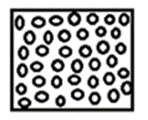
Clay soil
Qn. Write down any two characteristics of clay soil.
(i) Clay soil has fine particles.
(ii) Clay soil has tiny air spaces.
(iii) Clay soil has closely packed particles.
(iv) Clay soil has little humus.
(v) Clay soil retains water for a long time.
(vi) Clay soil has the highest capillarity.
Qn. Give a reason why clay soil retains water for a long time.
Clay soil has tiny air space.
Qn. Why is clay soil used in modelling?
Clay soil is sticky.
Qn. State any two uses of clay soil.
(i) Clay soil is used for making pots, cups and plates.
(ii) Clay soil is used for making bricks.
(iii) Clay soil is used for making roofing tiles.
A diagram showing arrangement of particles in clay soil.
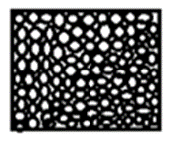
Sand soil
Characteristics of sand soil.
(i) Sand soil has large particles.
(ii) Sand soil has large air space.
(iii) Sand soil dry up quickly.
(iv) Sand soil does not contain humus.
(v) Sand soil has the highest rate of drainage.
(vi) Sand soil has the lowest rate of capillarity.
Qn. Give a reason why sand soil does not retain water for a long time.
Sand soil has large air spaces.
Uses of sand soil
(i) Sand soil is used for making glasses.
(ii) Sand soil is used in building.
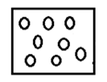
A diagram showing arrangement of particles in sand soil.

SOIL DRAINAGE
Qn. What is soil drainage?
Soil drainage is the downward movement of water in the soil.
OR: The capacity of the soil to allow water pass through it.
Experiment to show soil drainage
Things / equipment needed
(i) Samples of sand, loam and clay soil.
(ii) Empty bottle
(iii)Cotton wool
(iv) Funnel
STEPS
(i) Get samples of dry sand soil, clay soil, loam soil and three funnels, three bottles of equal size and cotton wool.
(ii) Put some cotton wool in each funnel.
(iii) Put each type of soil in separate funnel.
(iv) Place each of the funnel in a bottle and pour equal amount of water into the soil in the funnel.
(v) Observe what happens as water flows through each type.
(vi) Measure the amount of water collected in each bottle using a measuring cylinder.
Illustration
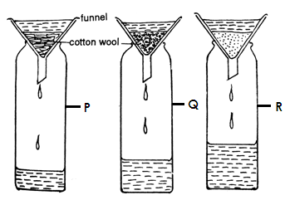

Qn. What does the experiment above show?
Soil drainage
Qn. Name the type of soil in container marked;
(i) P - clay soil
(ii)Q - loam soil
(iii)R - sand soil
Qn. Give a reason why much water collects in container marked R.
The soil in container R has large air spaces.
Qn. Give a reason why little water collects in container P.
The soil in container P has tiny air spaces.
Qn. Which type of soil has the highest rate of drainage?
Sand soil
Qn. Name the type of soil with the lowest rate of drainage.
Clay soil
SOIL CAPILLARY
Qn. What is soil capillarity?
Soil capillarity is the upward movement of water in the soil.
Qn. Name the type of soil which has the highest rate of capillarity.
clay
Qn. Which type of soil has the lowest rate of capillarity?
Sand
An experiment to find out the capillarity of different soils.
Steps:
(i) Fill three long glass tubes with ends open with sand, clay and loam soils.
(ii) Plug the lower end of each glass tube with some cotton wool.
(iii) Put the glass tubes in a trough with water.
(iv) After few hours the water level rises through the soils in each glass tube.
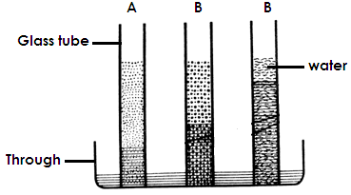
Illustration

Qn. What does the experiment above show?
Soil capillarity
Qn. Identify the type of soil in glass tube.

(i) A - sand soil
(ii) B - Loam soil
(iii) C - Clay soil

Qn. Why does more water move upwards in glass tube C?
The soil in glass tube C has tiny air spaces.
Qn. Why does little water move upwards in glass tube A?
The soil in container A has large air spaces.
COMPONENTS OF SOIL
Qn. List down at least four components of soil.

- Humus
- Air
- Water
- Living things/organisms
- Rock particles
- Dissolved mineral salts

WATER
Qn. State the importance of water in the soil.
(i) Water is used by plants during germination.
(ii) Water is used by plants during photosynthesis.
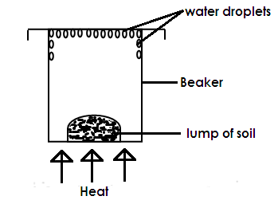
(iii) It dissolves mineral salts.
Experiment to show that soil contains water.

Qn. What does the experiment above prove about soil?
Soil contains water.
Qn. What do the water droplets represent?
Water escaping from the soil as water vapour.
Qn. What do the arrows represent?
Heat
AIR
Qn. State the importance of air in the soil.
- It is used by the seeds during germination.
- It is used by plant roots for respiration.
- It is needed by plants to carry out photosynthesis.
- It is used by the living things for respiration.
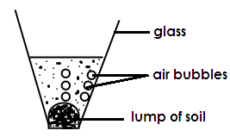
An experiment to show that soil contains air.

Qn. What do the air bubbles represent?
Air escaping from the soil.
Qn. What does the experiment above prove about soil?
Soil contains air.
LIVING THINGS / ORGANISMS
Qn. How are organisms useful in the soil?
- They aerate the soil
- Bacterial speed up the decay of dead plants and animal matter to form humus.
Qn. What is soil aeration?
- Is the circulation of air in the soil.
Qn. How do living things help in soil aeration?
- By creating tunnels in the soil.
Qn. Mention any two examples of living things found in the soil.

- Earth worms
- Bacteria
- Fungi
- Termites
- Mole rats

Qn. How do termites benefit from the soil?
- Termites get food from the soil.
- Soil acts as habitat for termites.
Qn. How are bacterial useful in the soil?
- They help in formation of humus.
- They help to decompose organic matter.
- Useful bacteria help to fix nitrogen in the soil.
ROCK PARTICLES
Qn. Which component of soil is formed as a result of weathering?
Rock particles.
Qn. State the importance of rock particles as a component of soil.
- They contain mineral salts necessary for plant growth.
- They create space for air to occupy.
DISSOLVED MINERAL SALTS
Qn. Mention any four important mineral salts found in the soil / necessary for plant growth.
- Iron - for formation of chlorophyll.
- Magnesium - for formation of chlorophyll.
- Phosphorus - for formation of strong plant cell wall.
- Calcium - Strengthen the plant stems and leaves.
- Potassium - helps plants to build resistance to diseases and drought.
- Nitrates and phosphates - to make plant proteins.
Qn. How are mineral salts important in the soil?
- They help to form chlorophyll.
- They make the plant cell wall strong.
- They enable the plant to resist diseases and drought.
Qn. By what process do plant roots absorb mineral salts from the soil?
Osmosis
HUMUS
Qn. Name the component of soil formed by decomposition of plant and animal matter.
Humus
Qn. How is humus important in the soil?
- Humus makes the soil fertile.
- Humus provides plants with nutrients.
- Humus makes the soil to appear dark.
- Humus makes the soil more water.
Qn. Mention any three properties of soil.
(i) Soil contains air.
(ii) Soil contains water.
(iii) Soil contains mineral salts.
Qn. Mention any uses of soil to plants.
- It supports plant growth.
- Soil provides plants with nutrients.
Qn. State the uses of soil to people.
- Loam soil is used for growing crops
- Soil is used for construction.
- Clay soil is used for making ceramics.
- Sand soil is used for making glasses.
- Sand soil is used for filtering water.
Qn. Mention the type of soil best for growing crops.
Loam soil
Qn. Give a reason why soil is the best for growing crops.
- It has a lot of humus.
- It has well balanced particles of sand and clay.
- It is well aerated.

Qn. Which type of soil is used for making ceramics?
Clay soil
SOIL PROFILE
Qn. What is soil profile?
Soil profile is the arrangement of soil layers from top to bottom.
OR
Is the vertical arrangement of soil layers.
Qn. Identify any two areas where soil profile can be clearly.
- Pit latrines
- Trenches
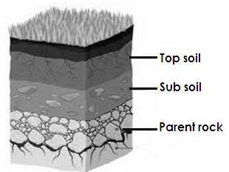
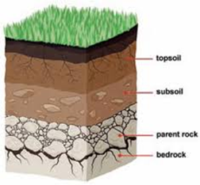
A diagram showing soil profile.

Qn. Name the soil layer which is good for growing crops.
Top soil
Qn. Give a reason why top soil is good for growing crops.
Top soil has a lot of humus.
Qn. Briefly explain these terms.
- Soil texture
Is the different sizes of soil particles.
- Soil structure
Is the way how soil particles are arranged in an area.
SOIL EROSION
Qn. What is soil erosion?
Soil erosion is the removal of top soil by its agents.
Qn. Mention any two agents of soil erosion.
- Fast running water
- Strong wind
- Moving animals
Qn. Give any four causes of soil erosion.
- Bush burning
- Deforestation
- Overgrazing
- Overstocking
- Monocropping
Qn. State one danger of soil erosion to crops.
It makes soil unsuitable for plant growth.
Types of soil erosion

- Splash erosion
- Sheet erosion
- Rill erosion
- Gully erosion
- River or bank erosion
- Wind erosion

(a) Splash erosion
This is the type of erosion where rain drops fall on bare land and splash or displace soil.
(b) Sheet erosion
This is the type of erosion where top soil is uniformly carried away by running water or wind.
(c) Rill erosion
This is the type of erosion where shallow channels are created on the land by slow moving water.
(d) Gully erosion
This is the type of erosion where big channels are created on the land by fast running water.
(e) River or bank erosion
This is the type of soil erosion that occurs near river banks.
(f)wind erosion
This is the type of erosion where soil from the earth’s surface is carried away by wind.
Qn. What is silting?
Silting is the deposition of silt or eroded materials into the water body.
Qn. State two causes of silting.
- Clearing vegetation around river banks.
- Deforestation
- Bush burning
- Cultivating near river banks
Qn. Give two effects of silting.

- Makes water body shallow.
- Leads to death of aquatic life.
- Leads to water pollution.

Qn. State any two ways of controlling silting.
- Avoiding clearing vegetation around river banks.
- Avoiding cultivating near river banks.
- Afforestation.
- Avoiding bush burning.
Qn. State any four ways of controlling soil erosion.

- Mulching
- Practicing crop rotation
- Through afforestation
- Re-afforestation
- Bush fallowing
- Terracing
- Contour ploughing
- Strip cropping
- Agro forestry

Qn. Give any two effects of soil erosion.
- It leads to soil exhaustion.
- It leads to poor yields in crops.
MULCHING
Qn. What is mulching?
Mulching is the covering of soil using dry plant materials.
Qn. Write down any two advantages of mulching.
- Mulching keeps moisture in the soil.
- Mulching controls soil erosion.
- Mulching improves soil fertility.
- Mulching prevents the growth of weeds in the garden.
Qn. State any two disadvantages of mulching.
- Mulches hide pests.
- Mulches can be fire hazards.
- Some mulch can grow as weeds.
Qn. What are mulches?
Are materials used for mulching.
Qn. Mention any two examples of materials used as mulches in the garden.
- Dry grass - coffee husks - Banana leaves - wood shaving
- Maize stalks
Qn. How does mulching control soil erosion?
- Mulches reduce the speed of fast running water.
Qn. How does mulching keep moisture in the soil?
- Mulching reduces evaporation of water from the soil.
Qn. How does mulching improve on soil fertility?
- Mulches rot and form humus.
Qn. Why do we use dry mulches when mulching?
- They can easily rot.
Qn. Give a reason why fresh plant materials cannot be used for mulching.
- They can easily turn into weeds.
CROP ROTATION
Qn. What is crop rotation?
- Is the growing of different crops on the same piece of land seasonally.
Advantages of crop rotation
(i) Crop rotation controls soil erosion.
(ii) Crop rotation controls crop pests and diseases.
(iii) Crop rotation improves soil fertility.
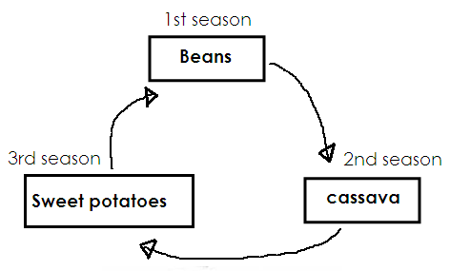
Illustration showing crop rotation

Qn. How does crop rotation control crop pests?
- It breaks the life cycle of pests.
Qn. How does crop rotation improve soil fertility?
- It involves the growing of legumes.
- Legumes add plant nutrients to the soil.
TERRACING
Qn. What is terracing?
- Is the digging of terraces on a slop or hilly area.
Qn. How does terracing help to control soil erosion?
- Terraces slow down the speed of running water.
- Terraces reduce the speed at which water flows down hill.
Qn. State any two ways of controlling soil erosion in a school compound.
- Planting short grass
- Using pavers
- Cementing the compound
- Planting trees
Qn. In which season is mulching done?
- Wet season
Qn. How does crop rotation control soil erosion?
- It involves the growing of cover crops.
Qn. Explain the following terms.
(a) Strip cropping.
- Is the growing of crops on strips a cross the slope.
(b) Contour ploughing
- Is the ploughing of land across the slope.
- Soil leaching
- Is the loss of soil nutrients from the upper layers to the deeper layers of the soil where plant roots cannot reach them.

Qn. Mention the causes of leaching.
- Rain water
- Soil exhaustion
Is the loss of soil fertility?
Qn. State two causes of soil exhaustion.

- Leaching
- Deforestation
- Bush burning
- Soil erosion

Ways of improving soil fertility.
Qn. What is soil fertility?
Soil fertility is the ability of the soil to support plant growth.
Qn. Identify any four ways of improving soil fertility.
(i) Using fertilizers
(ii) By mulching
(iii) Bush fallowing
(iv) Agroforestry
(v) crop rotation
Qn. Give the meaning of the following term.
(a) Bush fallowing
- Is the leaving of the land to grow bushy for sometime without cultivating it.
(b) Agro forestry
- Is the growing of crop, trees and rearing of animals on the same piece of land. FERTILIZERS
Qn. What are fertilizers?
Fertilizers are substances put in the soil to increase its fertility.
Types of fertilizers
(a) Natural fertilizers (organic manure)
(b) Artificial fertilizers (inorganic fertilizers)
Natural fertilizers
Qn. What are natural fertilizers?
These are manure got from decayed plants and animal materials.
Types of natural fertilizers
(a) Compost manure
(b) Farmyard manure (FYM)
(c) Green manure
(d) Organic mulches
Compost manure
Qn. What compost manure?
Compost manure is the type of manure got from decayed plants and animal wastes.
Things used to make compost manure
(i) Banana peelings
(ii) Plant leaves
(iii) Leftover food
(iv) Maize stalks
(v) Cassava peelings
Methods of making compost manure
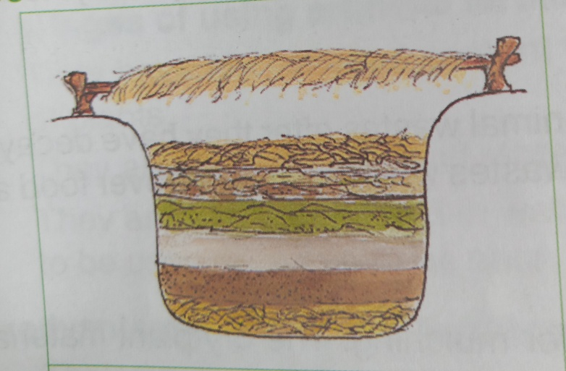
(a) Pit method

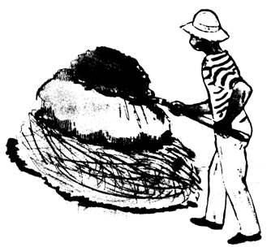
(b) Heap method

Qn. Why do we put hard materials like maize stalks at the bottom of the pit?
- To trap nutrients
- To allow air to the compost materials to rot quickly.
Qn. Why do we add some farmyard manure to the compost materials?
To provide organisms that cause decaying of matter.
Qn. State the importance of ash and saw dust added to compost materials in the pit.
To improve on the nutrients content.
Qn. Why is a layer of top soil added to the decaying materials?
To increase the rate of rotting of organic matter.
Qn. Why should the materials in the pit be turned from time to time?
To make sure all materials rot.
Qn. Why is water sprinkled on the compost pit?
To speed up rotting
Qn. State the importance of a stick when making compost manure.
To check on the decomposition process
GREEN MANURE
Qn. What is green manure?
Green manure is the type of manure where young growing crops are ploughed into the soil.
Qn. Which group of crops is used to make green manure?
Leguminous crops
Qn. Why are legumes used in making green manure?
They have high nitrogen content.
Farm yard manure (FYM)
Is the type of manure got from animal wastes.
Materials used to make farm yard manure
- Cow dung
- Animal Urine
- Chicken droppings
- Goat droppings
Organic mulches
It is the type of manure got from decayed mulches.

Materials used to make organic mulches
- Coffee husks
- Saw dust
- Wood shaving
- Rice husks
Advantages of organic manure/natural fertilizers
- They are rich sources of humus to the soil.
- they improve on the soil structure
- they are cheap
- Natural fertilizers stay longer in the soil.
- They don’t pollute the soil.
Disadvantage of organic manure
- They are tiresome to make.
- They produce bad smell.
- They are bulky.
- They take long to release nutrients.
ARTIFICIAL FERTILIZERS
These are fertilizers made from factories.
Artificial fertilizers are divided into two namely;
(a) Straight fertilizers
(b) Compound fertilizers
Qn. What are straight fertilizers?
These are fertilizers that supply the soil with one nutrient.
Examples of straight fertilizers.
(i) Single super phosphate (SSP)
(ii) Double super phosphate (DSP)
(iii) Triple super phosphate (TSP)
Qn. What are compound fertilizers?
These are fertilizers that supply the soil with more than one nutrient.
Examples of compound fertilizers
(i) NPK fertilizers
(ii) Dia-ammonium phosphate (DAP)
Advantages of artificial fertilizers
- They are quick in improving soil fertility.
- They are easy to store.
- They are easy to apply.
- They can easily dissolve in water.
- They have high nutrient content.
Disadvantages of artificial fertilizers
- They are expensive.
- They need special skills to use them.
- They stay in the soil for a shorter time.
- They can cause poisoning.
- They can cause water pollution.
Qn. Identify three methods used to apply fertilizers in the soil.
- Placement method.
- Broadcasting method.
- Spraying method.
- Top dressing.
Qn. Suggest one danger of excessive use of chemical fertilizers to the soil.
- They destroy the structure and nature of the soil.
- Soil loses its ability to generate its own fertility.
- They pollute the soil
SOIL POLLUTANTS/HARMFUL MATERIALS TO THE SOIL
- These are substances that pollute the soil.

OR:
These are substances that spoil the good quality of soil.

Examples of soil pollutants/harmful materials to the soil

- Polythene papers
- Plastics
- Metal scraps
- Broken bottle
- Chemicals
- Waste oil
- Nails

Qn. Give two effects of polythene papers harmful to the soil.
- They prevent water and air from entering the soil.
- They pollute the soil.
- They make the soil become infertile.
Qn. State two effects of chemicals on soil.
- They lead to death of useful organisms in the soil.
- They destroy soil structure.
Qn. How are waste oils harmful to the soil?
- They prevent the air and water from entering the soil.
Effects of harmful materials on soil.
(i) They kill useful organisms in the soil.
(ii) They lead to soil infertility.
(iii) They prevent air and water from entering the soil.
(iv) They pollute the soil.
(v) They destroy soil structure.
Qn. What are soil barriers?
These are things that prevent soil erosion to take place.
Examples of soil barriers.

- grass
- tree roots
- terraces
- contours
- concrete walls
- gabions

TOPIC SIX
MATTER AND ENERGY
Qn. What is energy?
- Energy is the ability to do work.
Qn. What is matter?
- Matter is anything that occupies space and has weight.
Qn. What is matter made up of?
- Matter is made up of molecules.
Qn. What are molecules?
- Molecules are small particles that make up matter.
Qn. What is an atom?
- An atom is the smallest indivisible particle that make up matter.
Qn. Describe these terms as used in matter.
(a) Volume
- Is the space occupied by an object.

(b) Mass
- Is the amount of matter in an object.

- Weight
- Is the gravitational force acting on an object.
Examples of matter
- Books - blood - rulers - water - human body
- Air - pens - urine - stones - A piece of chalk
- Milk - water - sets
Properties of matter
(i) Matter has weight
(ii) Matter occupies space.
(iii) Matter exerts pressure.
Qn. Why is air regarded as matter?
STATES OF MATTER
These are three states of matter namely;
(a) Solids (solid state)
(b) Liquids (Liquid state)
(c) Gases (Gases state)
SOLIDS
Solids are objects with definite shapes and volume.
Characteristics of solids
(i) The molecules are very closely held together.
(ii) Molecules do not move.
(iii) They have definite shape.
(iv) Solids have weight, mass and volume.
(v) Heat travels through solids by conduction.
(vi) Solids have greater cohesion force.
Examples of solids
- Books - A ruler - stones - pencils - desks - plates
- tree
Qn. What is cohesion?
Is the force of attraction between molecules of the same kind.
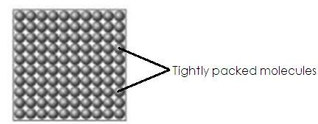
Illustration showing arrangement of particles in solids.

LIQUIDS
Characteristics of liquids
- The molecules are loosely packed.
- Liquids do not have shape.
- Molecules are free to move.
- Heat travel through liquids by convection.
- They have less cohesion force.
Examples of liquids
- Water - soda - Milk - juice - cooking oil
An illustration showing the arrangement of molecules in liquids.
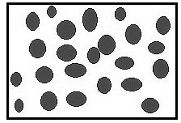

GASES
Characteristics of gases
- The molecules are far apart from each other.
- The molecules a free to move.
- Gases do not have shape or size.
- Heat travel through gases by convection.
- Gases have no cohesion force
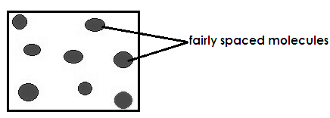
An illustration showing the arrangement of molecules in gases.

Qn. What is adhesion force?
Is the force of attraction between molecules of different kind.

ENERGY
Energy is the ability to do work.
Types of energy
(a) Kinetic energy
(b) Potential energy
Potential energy
Qn. What is potential energy?
Potential energy is the type of energy possessed by objects at rest.
Examples of potential energy
- Books resting on the teacher’s table.
- A set resting on the desk.
- A baby sleeping in a cot.
- A stone resting on the ground.
Qn. What is kinetic energy?
Kinetic energy is the type of energy possessed by an object in motion.
Examples of kinetic energy.
- Ball rolling on the ground.
- A girl running
- A leaf falling from the tree.
- A bird flying
A diagram showing potential and kinetic energy.
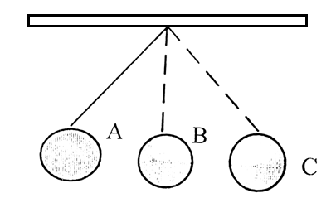
(a) A swinging pendulum.

Qn. What type of energy is possessed by the pendulum at;
(i) A potential energy(ii) B Kinetic energy
(iii)C Potential energy
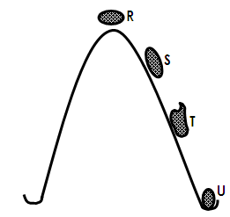
Qn. Identify the type of energy possessed by the stone at point R, S, T and U>

R - Potential energy
S - Kinetic energy
T - Kinetic energy
U - Potential energy
Qn. Write down two energy changes that take place at point U in the diagram above.
(i) Kinetic energy changes into potential energy.
(ii) Kinetic energy changes into sound energy.
- Kinetic energy changes to heat energy.
Qn. Mention two forms of energy produced by the stone when it reaches point U.
- Sound energy
- Heat energy
FORMS OF ENERGY

- Heat energy
- Light energy
- Sound energy
- Solar energy
- Chemical energy
- Electric energy
- Magnetic energy

Characteristics of forms of energy
(i) All forms of energy have the ability to do work.
(ii) They cannot be destroyed.
HEAT ENERGY
Qn. What is heat?
Heat is the form of energy that increases temperature of an object or place.
Sources of heat energy
(i) Natural source of heat
(ii) Artificial source of heat
Qn. What are natural source of heat?
These are objects that give out heat naturally.
Examples of natural source of heat.
- The sun
- Stars
- Lightning
- Erupting volcanoes
- Food decaying matter
Qn. What are natural artificial sources of heat?
These are people made objects that give out heat.
Examples of artificial sources of heat.
- Red hot charcoal - Electric bulbs - Friction - candles
- Electricity - Firewood - Paraffin - Petrol
Qn. Give two uses of heat energy in our daily life.
- Heat is used to dry harvested crops.
- Heat is used to dry washed clothes.
- Heat is used to cook food.
- Heat warms our body.
- Heat used in ironing clothes.
- It helps in rain formation.
Effects of heat on matter.
(i) Matter increases the temperature of matter.
(ii) Matter expands when heated.
(iii) Heat causes change in states of matter.

Changes in states of matter
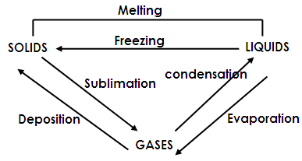

Evaporation is the physical change of state of matter from liquids to gases.
Condensation is the physical of state of matter from gases to liquids.
Melting is the physical change of state of matter from solids to liquids.
Freezing is the physical change of state of matter from liquids to solids.
Sublimation is the direct changing of a solid into a solid.
Deposition is the direct changing of a gas into a solid.
Qn. What are sublimates?
These are substances that can change directly from solids to gases.
Examples of sublimates.
- Mothballs
- Iodine
- Solid carbon dioxide
- Ammonium chloride salt
- Naphthalene
Qn. Name the instrument that measures heat.
Calorimeter
Qn. In which units is heat measured?
Calories
Expansion and contraction of matter
Qn. What is expansion?
This is the decrease in size of an object.
Qn. What is contraction?
This is the decrease in size of an object.
An experiment to show that matter expands when heated.
(i) Using a metallic ball and ring equipment.
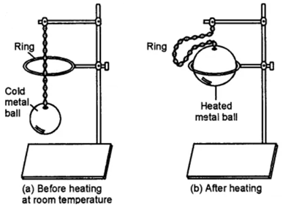

Qn. What does the experiment above show?
The experiment shows that solids expand when heated.
Qn. Why did the metallic ball fail to pass through the ring after heating it?
The metallic ball has expanded.
Qn. What happens when the metallic ball is left to cool for some time?
The metallic ball contracts and passes through the ring.
(ii) The bimetallic strip
Is a strip that consists of two different metals.
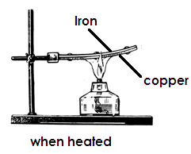
Illustration
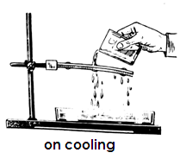

Qn. Which of the two metals expands faster?
Copper
Qn. Give a reason for your answer above?
- Copper expanded and bent over iron.
- Copper expands faster than iron.
Qn. Which metal cools faster?
Copper
Qn. Give two uses of bimetallic strips.
(i) They are used in thermometer switches of flat irons.
(ii) They are used in thermostat switches of electric kettles.
(iii) They are used in thermostat switches of refrigerators.
Application of expansion in our daily life.
(a) Railway lines
Qn. Why are gaps left between railway lines?
To give room for expansion during hot days.
Qn. What would happen if the gaps were not left between railway lines?
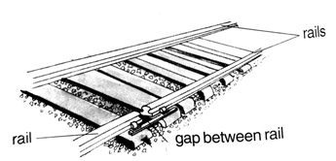
Lines would expand and bend or beak.
Illustration

Illustration
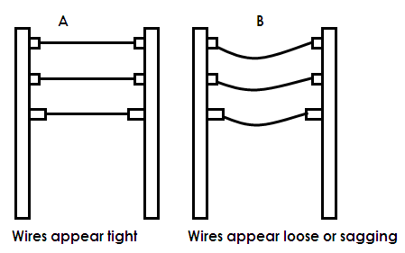
(b) Telephone and electricity wires.

Qn. At what time of the day do electric wires appear as shown in the diagrams above?
- Cold days
- Hot days
Qn. Why do electric wires appear tight during cold days?
Due to contraction
Qn. Why do electric wires appear loose during hot days?
Due to expansion
Qn. Why are electric wires fixed loosely on electric wires?
To give room for expansion and contractor during cold and hot days.

Effects of heat on liquids.
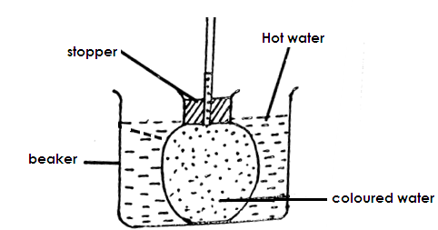
Study the diagram below and use it to answer the questions that follow.

(a) What does the experiment above show?
Expansion in liquids
Qn. Why does the level of water fall down for seconds after putting the flask in hot water?
Due to expansion of the flask.
Qn. Why does the water level rise up when the flask is left in hot water for some time?
Coloured water expands more than the flask.
Qn. Give a reason why space is left when bottling soda?
To give room for the increase in the volume of soda when frozen.
Effects of heat on liquids.
(i) Liquids expand when heated.
(ii) Liquids evaporate when heated.
Qn. What happens to the following when water turns into ice (frozen)
(i) Volume - increases
(ii) Density - decrease
(iii) Mass - remain the same
Effects of heat on gases
Gases expand when heated.
Use the diagram below to answer the questions that follow.
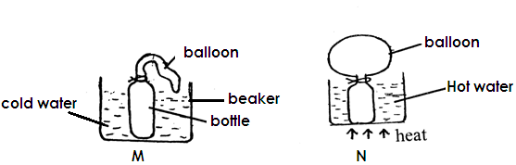

Qn. What does the experiment above show?
Gases expand when heated.
Qn. Why does the balloon expand in diagram N?
Due to expansion of air inside the bottle.
Qn. Why does as inflated balloon burst when left in sunshine for a long time?
Due to expansion of air inside the balloon.
HEAT TRANSFER
Is the movement of heat from one point to another.
Methods of heat transfer
- Conduction
- Convection
- Radiation
Qn. How does heat travel through the following?
(A) Solids - Conduction
(B) Liquids - Convection
(C) Gases - Convection
(D) Vacuum or space - Radiation
Qn. What is a vacuum?
A vacuum is space without matter.
Qn. In which state of matter does heat travel?
(i) fastest - gases
(ii) Faster - Liquids
(iii) Fast - solids
Qn. Why does heat travel fastest in gases?
The molecules in gases are far apart from each other and freely move.
Qn. Why does heat travel slowest in solids?
The molecules are tightly together and cannot move.
Heat transfer in solids
Study the experiment below and use it to answer the questions that follow.
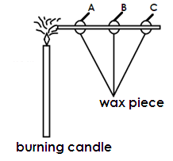

(a) Which wax piece will melt first?
Wax piece A
(b) Give a reason to support your answer in (a) above.
It receivers heat first.
(c) Which wax piece will melt last?
Wax piece C.
(d) Give a reason for your answer in (c) above.
Wax piece C receives heat last.
Qn. State the importance of the wax piece in the experiment?
Wax pieces show the movement of heat in the nail.
Qn. Give the importance of the nail.
It helps in heat transfer
Qn. What does the experiment above show?
Heat transfer by conduction
Importance of heat transfer by conduction.
(i) Heat transfer by conduction enables us to cook food.
(ii) It enables us to iron clothes.
(iii) It enables us to boil water.
Heat transfer us to boil water
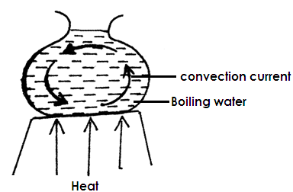
Qn. Study the diagram below and use it to answer the question that follow.

Qn. What does the experiment above show?
Convection in liquids
Qn. What do the arrows represent?
Convection currents.
Qn. By what process does all the water in the saucepan get heated up?
By convection
Qn. By what process does heat pass through the saucepan to reach the water?
By conduction.
Qn. What does the experiment below show?
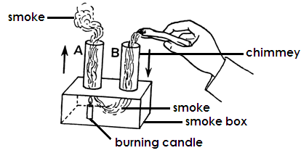

- Convection in gases
Qn. Why does heated air rise up?
It expands and becomes lighter.
Qn. Why does smoke rise up when burning rubbish?
Smoke is less dense than fresh air.
Qn. State any four uses of convection in our daily life.
- Convection currents enable people to light charcoal stoves and keep the charcoal stoves burning.
- Convection currents help in air circulation in a house.
- Convection current help to take our bad smell from the latrines.
- Convection currents help to take out smoke from the kitchen.
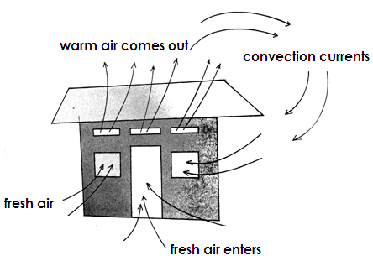
Movement of air inside and out of the house.

Qn. State the importance of each of the following on a living house.
(a)Doors - Let in fresh air
- Let in light into the house
- Act as exit and entrance
(b) Ventilators - Let out warm air
- Let in fresh air
(c) Windows - Let in fresh air
- Let in light
Qn. Why are ventilators put above windows and doors?
Ventilators let out warm air which has less density than fresh air.
Qn. Why are windows placed below ventilators?
Windows let in fresh air which has more density than warm air.
Qn. Give the importance of proper ventilation on a living house.
- It prevents suffocation
- Prevents the spread of air borne disease.
Use the diagram below to answer the questions that follow.
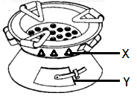
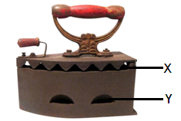
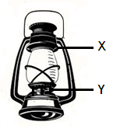

Qn. State the function of the holes marked X and Y on the diagram.
(i) X - To let out warm air.
(ii) Y - To let in fresh air.
Qn. Besides allowing in fresh air, how else is hole Y important to the charcoal stove and iron box.
Let out ash
Qn. Why is the handle of the iron box made of wood?
To prevent the users hands from being burnt.
Qn. By what process does paraffin move up the wick of the kerosene lamp (lantern)?
Capillary attraction
BREEZE
A breeze is a coal gentle wind blowing from one place to another.
Types of breeze
(a) Land breeze
(b) Sea breeze
Qn. What is a land breeze?
Is the movement of coal gentle wind from land to sea.
Qn. When does a land breeze occur?
At night
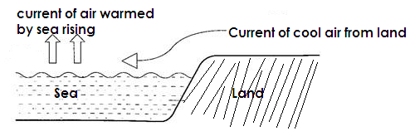
An illustration showing a land breeze

Qn. What is sea breeze?
Is when cool air blow from the sea to the land.
Qn. When does a sea breeze take place?
Day time

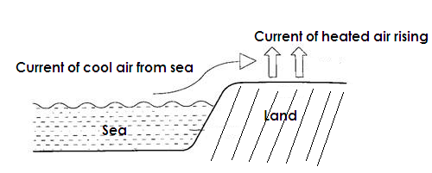
An illustration showing a sea breeze

Heat transfer by radiation
Radiation is the process by which heat travel through space or vacuum.
Qn. Give any two uses of heat transfer by radiation
- Radiant heat helps in drying crops.
- Radiant heat helps in drying wet clothes.
- Heat transfer by radiation warms our bodies.
- Radiant heat causes evaporation of water in a rain cycle.
Qn. How does heat from the sun and reach the earth?
By radiation
REFLECTS AND ABSORBERS OF HEAT
Qn. What are reflectors?
Reflectors are shiny surface that reflect heat and light.
Examples of reflectors of heat.
(i) Mirrors
(ii) Glasses
Qn. What are absorbers?
Are dull surfaces that absorb heat and light.
Examples of heat absorbers
- Black clothes
- Black cars
Qn. Why are most cars and houses painted white?
To reflect light.
Mary washed a black and white shirt. She spread them under sunshine at the same time.
Qn. Which shirt dried first?
Black shirt
Qn. Give a reason for your answer above.
A black shirt absorbs heat.
Qn. Which shirt dried last?
White shirt
Qn. Give a reason for your answer
A white shirt reflects heat.
CONDUCTORS AND INSULATORS
Qn. What are conductors of insulators?
Conductors are objects that allow heat pass through them easily.
Examples of conductors of heat.
- Silver - Zink - Copper - Lead - Iron
- Tin - Aluminium - Steel
Qn. What are insulators of heat?
Insulators are objects that allow heat to pass through them easily.
Examples of insulators.
- Plastics - Rubber - Wood - Papers - Clothes
Uses of conductors of heat.
- Conductors of heat are used to make cooking utensils.
- They are used to make electric wires.
- They are used to make bottoms of flat iron.
Uses of insulators of heat.
- They are used to make handles of flat irons.
- They are used for lifting hot saucepans.
- They keep our body warm.
Qn. Why are most cooking utensils made of aluminum not silver?
Aluminum is cheap and light white silver is expensive.
An experiment to prove that water is a bad conductor of heat.
Study the diagram below carefully and use it to answer questions that follow.
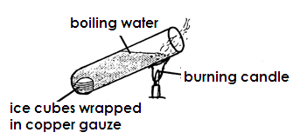

Qn. What does the experiment above show?
Water is a poor conductor of heat.
Qn. What will happen to the ice cubes at the bottom of the ice tube?
The ice cubes will not melt.
Qn. Give a reason to support your answer?
The heat at the bottom will not reach the ice cubes at the bottom because water is a poor conductor of heat.
THE THERMOS FLASK OR CACUUM FLASK
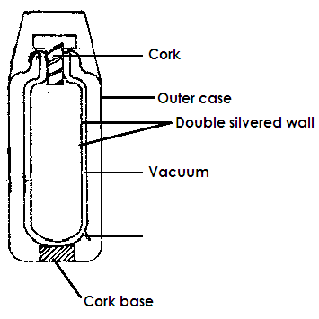
It keeps hot things hot and cold things cold.

Vacuum seal

Importance of the parts of a thermos flask.
(a) Cup - For taking the content in the flask
(b) A cork - To prevent heat loss by conduction.
(c) Metal case - To protect the inside parts of the flask.
(d) Vacuum - To prevent heat loss by conduction and convection.
(e) Double silvered wall / silvered surface - To prevent heat loss by radiation.
(f) Vacuum seal - To prevent matter from entering if from breaking.
Qn. Why are thermos flasks not common in most homes in rural areas?
- They are expensive
- They are delicate
TEMPERATURE
Temperature is the degree of colours or hotness of an object or a place.
Qn. In which units is temperature measured?
Degrees
Temperature scales
- Celsius on centigrade scale.
- Fahrenheit scale.
Note:
(i) The freezing point of water on the Celsius scale is 0⁰c and 320F on the Fahrenheit scale.
(ii) The boiling point of water on the centigrade scale is 100⁰c and 212⁰F on the Fahrenheit scale.
Types of thermometers.
(i) Clinical or doctors thermometer.
(ii) Six’s or minimum and maximum thermometer
(iii) Wall thermometer
(iv) An ordinary scientific thermometer

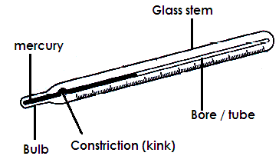
CLINCAL THERMOMETER

Qn. State the function of the clinical thermometer.
To measure the human body temperature.
Functions of each part
(a) Bulb - to store mercury
(b) Kink - to prevent the backflow of mercury.
(c) Stem - to protect the inside parts of the thermometer.
(d) Bore - It has a regular scale that shows the measurements.

Qn. Why does the scale of the clinical thermometer run from 34⁰C to 42⁰C?
The human body temperature cannot fall below 34⁰C and rise above 42⁰C.
Qn. Name the liquid metal used in clinical thermometer.
Mercury
Qn. Identify any two body parts where a clinical thermometer can be placed or put.
- In the mouth under the tongue
- Anus
- Under the armpits
- Vigina
Qn. Give a reason why the clinical thermometer is put in the above mentionedparts.
The bulb can be completely covered in the above parts to get the accurate temperature.
Qn. Why do health workers shake the thermometer before using it?
To allow mercury flow back to the bulb.
Qn. Give a reason why a clinical thermometer is sterilized using alcohol but not boiling.
To prevent it from bursting
Characteristics of a clinical thermometer.
(i) It has an arrow that points to 370C.
(ii) The scale starts from 340C to and ends at 420c.
(iii) It has a kink or constriction.
The six’s (maximum and minimum) thermometer
- It consists of the maximum and minimum thermometer combined into one.
- It has two arms. The left arm shows the minimum temperature while the right arm shows the maximum temperature.
- The six’s thermometer uses both alcohol and mercury.
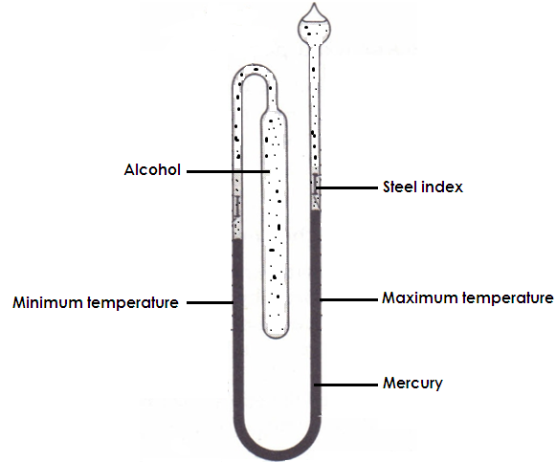
Diagram showing a six’s thermometer.

Qn. Why is alcohol used in the arm for measuring minimum temperature?
Alcohol has a low boiling point.
Qn. Why is mercury used in the arm for measuring maximum temperature?
Mercury has a higher boiling point.
The wall thermometer
- This is a thermometer used to measure room temperature.
- It uses either mercury or coloured alcohol.
- Its scale stops at 60⁰C because the temperature of air never rises over that.
Ordinary scientific thermometer.
- This is the thermometer which is used to scientific experiment.
- It is used in incubators for chicks.
Qn. Give a reason why mercury is commonly used in thermometer.
- Mercury does not stick on the walls of the thermometer.
- Mercury is easily seen.
- Mercury is a good conductor of heat.
- Mercury has a regular expansion
Advantages of using alcohol.

(i) It does not solidify easily.
(ii) It expands quickly.

Reasons why water is not used in thermometers.
(i) Water sticks on the walls of the thermometer.
(ii) Water is not easily seen.
(iii) Water is a poor conductor of heat.
(iv) Water doesn’t have a uniform expansion.
Qn. Give any two differences between a clinical thermometer and a six’s thermometer.
(i) A clinical thermometer has a kink while a six’s thermometer does not.
(ii) A clinical thermometer is reset for use by shaking while the maximum and minimum thermometer are reset by using a magnet.
(iii) A clinical thermometer measures temperature of people while six’s thermometer measures temperature of a place.
TEMPERATURE SCALE CONVERSION
(a) Changing temperature from Celsius to Fahrenheit scales.
To change from centigrade to Fahrenheit temperature we use the formula.
⁰F = (0C x ⁹/₅ ) + 32⁰
Example:
⁰F = (⁰C x ⁹/₅) + 32⁰
16
= (80 x ⁹/₅) + 32⁰.
1
= 144 + 32⁰
= 176⁰F
Activity
Convert the following from degrees calcium to Fahrenheit scale.
(i) 35⁰C (ii) 20⁰C (iii) 0⁰C (iv) 100⁰C (v) 95⁰C
(vi) 55⁰C (vii) 10⁰C (vii) 40⁰C (viii) 15⁰C
(b) Changing temperature from Fahrenheit to centigrade scales.
To change from Fahrenheit scale to centigrade scale we use the formula.
⁰C = (⁰F - 32⁰) x ⁵/₉
Example:
Change 680F to degrees centigrade.
0C = (⁰F – 32⁰) x ⁵/₉
= (68⁰ – 32⁰) x ⁵/₉
4
= 36 x 5/9
1
= 20⁰C
Activity:
Convert the following temperature into degrees Celsius.
(i) 212⁰F (ii) 104⁰F (iii) 86⁰F (iv) 32⁰F (v) 50⁰F
(vi) 77⁰F (vii) 95⁰F (viii) 59⁰F
BURNING
Qn. What is burning?
Is a chemical reaction in which heat and light energy are produced.
Qn. What is fuel?
A fuel is anything that burns to produce heat and light.
Examples of fuels

- Firewood
- Charcoal
- Candle wax
- Kerosene
- Petrol
- Natural gas

Zones of a burning candle flame.

- Blue zone
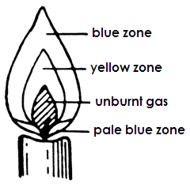
- Yellow zone
- Central zone
- Pale blue zone

BLUE ZONE

- It is the outer most region of the flame.
- It receives good supply of air.
- It is very difficult to see.

YELLOW ZONE
- It is the brightest part of the flame.
- It gives difficult to see.
CENTRAL ZONE (unburnt gas)
- It does not burn because air cannot reach it.
- It is deep inside the flame.
- It does not give light.
PALE BLUE ZONE
- It is at the bottom of the flame.
- It receives a very good supply of air.
- It is very hot.
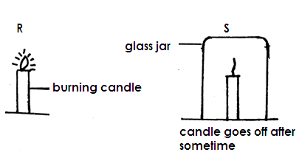
Use the experiment below to answer the questions that follow.

Qn(a) What does the experiment above show?
Oxygen supports burning.
(b) Why did the candle flame go off in diagram “S”?
The oxygen supply was cut off.
(c) Give two examples of gases found in part marked “x” in diagram S.

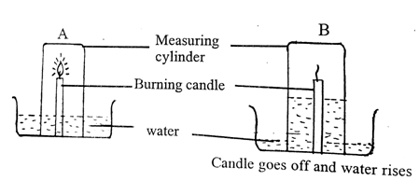
- Carbon dioxide
- Argon
- Neon
- Krypton
- Xenon

Study the experiment below and use it to answer the questions that follow.

Qn(a) What does the experiment above show?
Oxygen supports burning.
(b) Why did the candle go off in diagram B?
Oxygen that supports burning got used up.
(c) Why did the water rise up in B after the candle had gone off?
To occupy the space for the used up oxygen.
PUTTING OUT FIRE
- By using fire extinguishers
- By using sand
- By using heavy or thick blankest
- By using foam
Qn. Why is it not advisable to put out petrol fire using water?
Petrol will float on water and continue burning.
Qn. Why is carbon dioxide used in fire extinguishers?
It doesn’t support burning.
RUSTING
Qn. What is rusting?
Rusting is a chemical reaction that needs the presence of water and oxygen to take place.
Conditions necessary for rusting
(i) Presence of oxygen
(ii) Presence of water
Metals that can rust.
- Steal
- Iron
Metals that do not rust include
- Copper
- Aluminium
- Gold
- Stainless steal
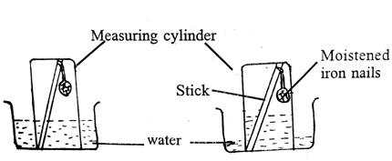
- Brass
Use the experiment below to answer the questions that follow.

(a) What does the experiment above show?
Oxygen
(b) Why did the water level rise up in experiment N?
To occupy the used up space for oxygen.
(c) State any one advantage of rusting.
- Rusting enables soil to get iron.
- Reduces metal scraps in the environment.
(d) Give two disadvantages of rusting.
- Rusting makes metals weak.
- Sharp objects become blunt.
- Water in rusty containers is poisonous.
- Rusting makes keys fail to open padlocks.
(e) State any two ways of preventing metals from rusting.

(i) By painting
(ii) By oiling / greasing
(iii) By keeping metals in cool dry areas.
(iv) By chromium plating
(v) By galvanizing metals.
(vi) By tin plating metals.
(vii) By enameling
(viii) Keeping metals in cool dry places
(ix) Making alloys

Qn. How does painting prevent metals from rusting?
Painting cuts off supply of oxygen and water to the metal.
MIXTURES
A mixture is a combination of two or more substances.

Examples of mixtures

- Rice and stones
- Beans and stone
- Salt and salt
- Oil and water
- Maize flour and iron fillings
- Air

Separating mixtures
Methods of separating mixtures
- By decantation - By sedimentation - By filtration
- Evaporation - Distillation - Using a magnet
- Using a separating funnel - By sorting - Hand picking
- Floating - sieving
1. Separating mixtures of solids and liquids.
(a) Mud and water or sand water
- By decantation
- By sedimentation
(b) Passion fruit juice from seeds
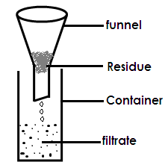
Filtration

(c) Salt and water
Evaporating to dryness (crystallization)
2. Separating liquids and liquids
(a) Separating pure alcohol from crudes alcohol or pure water from impure water.
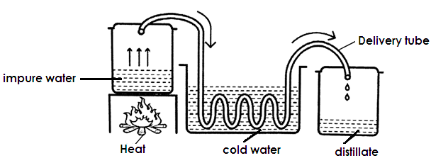
Distillation

Qn. Give a reason why distilled water is not good for drinking.
Distilled water does not contain mineral salts.
Qn. Give two uses of distilled water.
- It is used to mix drugs.
- It is used in drips.
Qn. Mention two physical processes involved in the distillation process.
- Evaporation
- Condensation
(b) Separating water and alcohol or paraffin and petrol.
Fractional distillation
(c) Water and oil or water and paraffin.
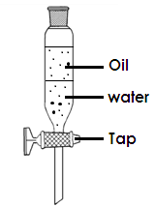
By using separating funnel

3. Separating solids and solids
(a) (i) Floatation
(ii) Hand picking
(b) Rice and stones or beans and stone.
(i) Sorting
(ii) Hand picking
(c) Beans or cereals and chaff
By winnowing
(d) Iron filling and maize flour
Using a magnet
Separating sand and salt
(i) Put the mixture of sand and salt in a container.
(ii) Pour water in the mixture and stir to dissolve salt.
(iii) Filter to remove sand.
(iv) Heat the solution and evaporate it to dryness.
MISCIBLE AND IMMISCIBLE LIQUIDS
Qn. What are liquids that can mix easily?
Miscible liquids are liquids that can mix easily.
Examples of miscible liquids
- Paraffin and petrol.
- Oil and paraffin
- Water and alcohol
Qn. What are immiscible liquids?
These are liquids that do not mix.
Examples of immiscible liquids
- Oil and water
- Water and paraffin
- Water and petrol
- SOLUTES, SOLVENTS AND SOLUTIONS
Qn. What is a solute?
A solute is a substance that can be dissolved by a solvent.

OR
A solute is a substance that can dissolve in a liquid.
Examples of solutes
- Salt
- Sugar
- Glucose
- Powdered milk
Qn. What is a solvent?
A solvent is a substance that dissolve a solute.
Examples of solvents
- Water
- Paraffin
- Soda
Qn. Why is water called a universal solvent?
Water dissolves all solutes.
Qn. Why does sugar disappear in tea?
Sugar is soluble in tea.
SOLUTION
Qn. What is a solution?
Is a mixture of a solvent and a solute.
Types of solutions
(i) Saturated solution
(ii) Super saturated solution
Qn. What is a saturated solution?
A saturated solution is a solution that cannot dissolve any more solute even after stirring.
Qn. What is a supper saturated solution?
A saturated solution is a solution that cannot dissolve any more solute even after heating.
SUSPENSION
Qn. What is a suspension?
A suspension is a mixture with undissolved particles that settle at the bottom on standing.
Types of suspensions
- Maize flour and water
- Mud and water
Solutes and insolubles
Qn. What are soluble?
These are substances that can dissolve in water.
Examples of soluble
- Sugar
- Salt
WORK
Qn. What is work?
Work is the product of force and distance moved in the direction of the force.
Qn. What is force?
Force is a pull or push on an object.

S.1 units
Work - Joules
Force - Newton
Distance - metres
CALCULATION
A man pushed a wheel barrow using 60 newtons through a distance of 4 metres. Find the work done.
WD = F x D
= 60 x 4
= 240 joules
Activity:
If a man uses 70N to push a wheelbarrow through a distance of 10metres. Find the work done.
Examples of forces
- Up thrust force / Buoyancy force
- Gravitational force
- Friction force
- Adhesion force
- Cohesion force
- Inertia force
Qn. What is inertia force?
Is the force that makes an object at rest remain resting or an object in motion to keep moving.
Types of inertia force
(i) Inertia at rest
(ii) Inertia motion
Qn. What is friction?
Is the force that opposes motion.
Types of friction
(i) Static friction
(ii) Sliding friction
(iii) Viscosity friction

Advantages
- Friction enables us to write.
- Friction enables to walk.
- Friction enables to sharpen objects.
- Friction enables cars to stop when brakes are applied.
- Friction enables us climb trees.
- Friction enables us climb Mountains.
- Friction enables us light match sticks.
Disadvantages of friction
(i) Friction causes unnecessary noise.
(ii) Friction causes unnecessary heat.
(iii) Friction causes wear and fear.
Disadvantages of friction
(i) Friction causes unnecessary noise.
(ii) Friction causes unnecessary heat.
(iii) Friction causes wear and fear.
Ways of reducing friction
- By oiling moving parts in machine.
- By grassing moving parts in machines.
- By streaming objects that move in fluids.
- Using ball bearing.
- Using rollers.
Ways of increasing friction.
(i) By putting pikes on sports books.
(ii) By putting treads on car tyres.
(iii) By putting treads on shoe soles.
(iv) By putting grips on handles of bicycle.
Qn. What is diffusion?
Is the movement of molecules of a substance from a region of high concentration to a region of low concentration?
Qn. What is dilution?
Dilution is the process of making a concentrated solution weak.
CROP GROWING
Qn. What is a crop?
A crop is any plant grown and cared for on a large scale.
Qn. Identify any two factors to consider when selecting a good planting materials / seeds.
- The planting should be whole without a hole.
- The seed should be whole without a hole.
- The seed should not be broken.
- The seed should not be mature.
- The seed should not be damaged by pests.
- The seed should be mature.
- The seed should not be damaged by parts.
Qn. Give any two factors to consider when selecting a good site for a garden.
- Fertility of the soil.
- Drainage of the soil
- Nearness to the water source.
- Nearness to a home or a school.
Qn. State any two importance of a garden / school garden.
- A school garden is a source of food to a school.
- A school garden is used for study purpose.
- It enables children know how to care for crops.
- It enables children know how different crops are planted.
TUBER CROPS
These are crops which have underground swollen stems or roots with food.
ROOT TUBERS.
Root tubers are underground swollen roots with food.
Examples of root crops

- Cassava
- Sweet potatoes
- Carrots
- Turnips

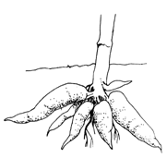 | 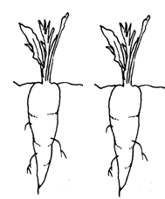 | 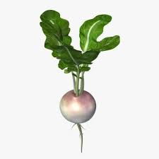  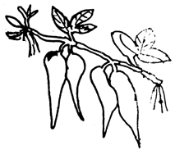
cassava | carrots | sweet potatoes | turnip

Propagating of root crops
Qn. What is plant propagation?
Propagation of plants is the way of making plants to multiply.
Qn. How are the following crops propagated?
- Cassava - planting crops propagated.
- Sweet potatoes - planting stem cuttings
- Carrots - planting stem cutting / vines
- Turnips - planting seeds
Harvesting of root crops
Qn. How are the following root crops harvested?
(a) Cassava
- By uprooting hands
- By digging using a hole.
(b) Sweet potatoes
- By uprooting using hands.
- By digging using a hole.
(c) Carrots
- By uprooting
- By digging using a hole
(d) Turnips
- By uprooting
- By digging using a hoe.
STEM TUBERS
Stem tubers are crops with underground swollen stems with food.
Examples of stem tubers
(i) Irish potatoes
(ii) White yams
Qn. How are the following crops propagated?
(a) Irish potatoes - by planting stem tubers.
(b) White yams - by planting stem tubers.
Qn. How are the following crops harvested?
a) Irish potatoes - by digging with a hole
(b) White yams - by digging with a hole.
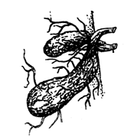 | 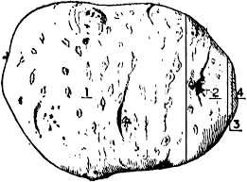
White yam | Irish potatoes

NOTE:
(i) The scale leaf protects the axillary bud.
(ii) The axillary bud develops into a short system
CARING FOR TUBER CROPS
Qn. Identify any four ways of caring for tuber crops.

- Weeding
- Thinning
- Watering
- Pests and diseases control

Row planting
Is the planting of crops in lines.
Advantages of row planting.
(i) Row planting reduces hiding places for pests.
(ii) Row planting makes thinning easy.
(iii) Row planting makes weeding easy.
(iv) Row planting makes pruning easy.
(v) Row planting leads to high leads.
Pruning
Is the removal of excess branches from the plant.

Advantages of pruning
(i) Pruning reduces hiding places for pests.
(ii) Pruning makes spraying and harvesting easy.
(iii) Pruning reduces weight of the plant.
(iv) Pruning reduces the rate of transpiration in plants
Qn. Name the garden tool used for pruning.
Secateurs
THINNING
Is the removal of excess and poor growing seedlings from the nursery bed or garden.
Advantages of thinning
(i) Thinning leads to high yields.
(ii) Thinning makes weeding, spraying and pruning easy.
(iii) Thinning reduces hiding places for pests.
(iv) Thinned materials can be used as mulches.
WEEDING
This is the removal of unwanted plants from the garden.
Ways of weeding / ways of controlling weeds.
(i) Spraying using herbicides.
(ii) By digging using a hoe.
(iii) By uprooting using hands.
(iv) By mulching the garden.
WEEDS
Weeds are unwanted plants in the garden.
Examples of weeds
- Star grass
- Couch grass
- Elephant grass
- Black jack
- Wondering jew
- Wild finger millet.
Advantages of weeds
(i) Some weeds are eaten as food.
(ii) Some weeds are used as mulches.
(iii) Some weeds are used as herbal medicine.
(iv) Wild weeds are used to thatch houses.
Disadvantages of weeds
(i) Weeds compete with plants for sunlight.
(ii) Weeds compete with plants for soil nutrients.
(iii) Weeds hide pests.
(iv) Weeds lead to poor yields.
(v) Weeds make spraying, harvesting and pruning difficult.
(vi) Some weeds are poisonous.
Advantages of weeding
(i) Weeding leads to high yields.
(ii) Weeding reduces hiding places for pests.
(iii) Weeding makes spraying, pruning and harvesting easy.
Plant staking
Is the providing of support to plants with weak stems using stick frames.
Trellising
Is the providing of support to plants with weak stems using strings.
Propping
Is the providing of support to plants with heavy bunches using poles.

Advantages of plant staking / trellising and propping.
(i) Makes weeding, spraying and harvesting easy.
(ii) Reduces hiding places for pests.
(iii) It leads to high yields.
(iv) Controls ground pests.
PESTS AND DISEASES OF TUBER CROPS
Qn. What is crop pest?
A crop pet is an organism that destroys crops.
Qn. What are vermin?
Vermin are animal pests
Characteristics of tuber crops pests.
(i) Some have sharp claws to dig out soil.
(ii) They have sharp incisors to gnaw at the tubers.
(iii) Some have fingers to uproot the plant.
Effects of pests to tuber crops
(i) Pests cause damage to the crops.
(ii) Pests spread diseases to crops.
(iii) Pests lead to poor yields.
(iv) Pests lower the quality of crops.
(v) Pests cause rotting of crops.
Table showing some pests and diseases and the crops they affect.
CROP | PESTS | DISEASES
Cassava | - White fly  - Mole rats  - Squirrels  - Monkeys  - grasshopper | - cassava mosaic  - Bacterial blight  - Wilt disease  - Leaf spot
Sweet potatoes | - Monkeys  - Sweet potatoes weevils  - Mole rats  - Squirrels  - grasshopper | - Bacterial blight  - Sweet potato mosaic  - Bacterial wilt
Carrots | - Nematodes  - Eel worms  - Cut worms  - Aphids  - grasshopper | - Bacterial wilt  - Leaf spot  - Leaf rust
Irish potatoes | - Nematodes  - Monkeys  - Aphids  - Irish potatoes | - Bacterial wilt  - Early blight  - Late blight
White yam | - Mole rats  - Nematodes  - Leaf beetles  - Caterpillar | - Leaf spot  - Leaf rust
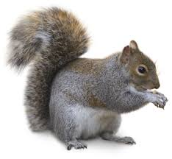
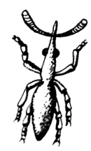 | 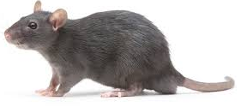 | 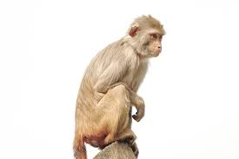
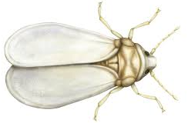  Squirrel | Rats | Monkey
 | 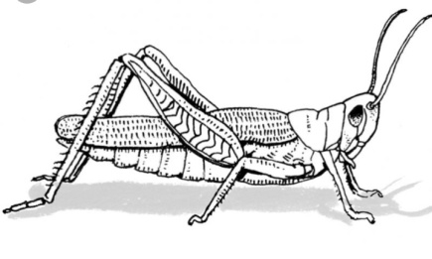
White fly | grasshopper | sweet potato weevil
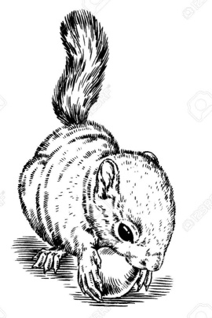
Signs and pests and disease damage in crops
- Yellowish leaves
- Holes leaves
- Curling of leaves
- Dark spots on leaves
- Brown spots on leaves
- Wilting of the plant
- Rotting of the tubers
- Black spots on leaves
Ways of controlling pests and diseases in the garden.
- By spraying using pesticides.
- By crop rotation
- By using crows
- By fencing the garden
- Trapping
- Using cats to eat rats
- Using lady birds to eat other insects
- Planting resistant crops
- Early planting
- Regular planting
- Poisoning
Ways of controlling pests in the store
- Using cats to eat rats.
- Using rat traps
- Putting rat guards on granaries
Storage of tuber crops
There are different methods of storage for crop produce namely;
- In granaries
- In silos
- In stores
- In sacks

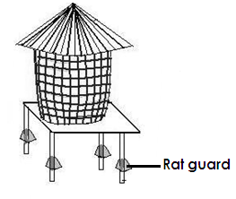 | 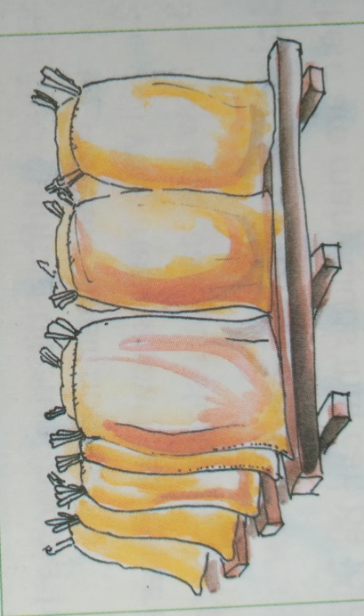
A food granary | Sacks on raised stands

NOTE
(i) Rat guards prevent rats from entering the granary.
(ii) Sacks are placed on dry pieces of wood to prevent moisture from the floor from spoiling the food.
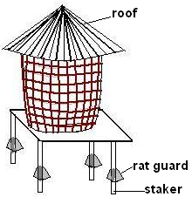
Characteristics for proper storage of food.
- The roofs of stores should not leak.
- Stores should have good ventilation.
- Rats guards should be fixed on the granary.
- The crop should be dried first before storing them.
SCEINCE CLUBS IN SCHOOL
Qn. What is a science club?
A science club is a club that involves members in activities related to science issues.
Examples of science oriented clubs
(i) Young farmers club.
(ii) First cross club
(iii) Science content club
(iv) Science and technology club
(v) Wild life club
State two importance of science clubs in schools
(i) They teach children modern methods of farming.
(ii) They teach children how to care for crops and animals.
(iii) They promote learning of school in schools.
(iv) Children become interested in science subjects.
(v) They enable children know how scientific work.
Young farmers clubs
Is a club made up of members who are interested in farming.
Importance of young farmers clubs in schools.
- They teach children how to care for crops.
- They teach children how to care for animals.
- They organize science tours.
- They teach children better methods of farming.
Co-operative society
A cooperative is a group who people who join together to do things they cannot do as individuals.
Importance of cooperative societies to famers
(i) They provide quality seeds to farmers.
(ii) They provide family tools to farmers.
(iii) They organize science tours.
(iv) They teach children better methods of farming.
TOPIC EIGHT
BACTERIA AND FUNGI
BACTERIA
Qn. What are bacteria?
Bacteria are tiny organisms made of a single cell.
Qn. How do bacteria reproduce?
By cell division or binary fission.
Qn. Identify any three places where bacteria are found.

- In air
- In water
- In the soil
- Bodies of sick animals
- pit latrines
- Rotting matter
- Root nodules.

Qn. Identify any three places where bacterial breed from.

- Rubbish pits
- Pit latrines
- Dirty wounds
- Dirty water
- Decaying matter

Qn. What are aerobic bacteria?
Aerobic bacteria are bacteria that need oxygen to respire.
Qn. What are anaerobic bacteria?
These are bacteria that do not need oxygen to respire.
An illustration to show cell division
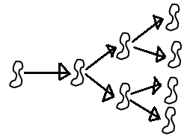

A diagram showing a bacterium
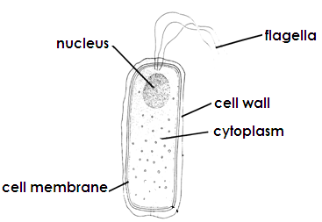

Qn. How do bacteria move?
By the use of the flagellum.
Types of bacteria
Qn. How are bacteria grouped?
- Their shape
- Their locomotion
- Their way of feeding
(a) Red – shaped bacteria (bacilli)
(b) Spherical shaped bacteria (cocci)
(c) Spiral shaped bacteria
(d) Comma shaped bacteria
Bacteria | Disease cause
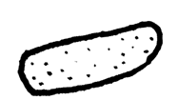Rod shaped bacteria  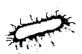 | tetanus  typhoid
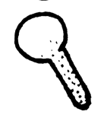 | tuberculosis
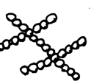Spherical bacteria  staphylococus  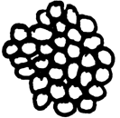  streptococcus  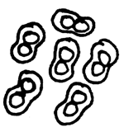  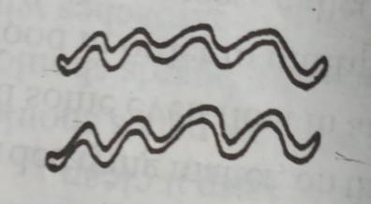 | sore throat  boils  pneumonia
Spiral bacteria | Syphilis
Bacteria | Disease cause
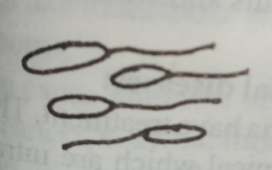Comma shaped | cholera
Natural of bacteria
(a) Useful bacteria
(b) Harmful bacteria
Qn. Give any two examples of useful bacteria
- Nitrogen fixing bacteria/nitrifying bacteria
- Petrifying bacteria
- Lactococcus lactis
- Bacillus coagulans
- Bifido bacterium
Uses of useful or harmful bacteria
- Some bacteria break down organic matter to form humus.
- Some bacteria help to fix nitrogen into the soil.
- Bacteria reduce the volume of faeces in pit latrine.
- Some bacteria are used to make vaccines.
- Some bacteria help in making yoghurt and cheese.
- Some bacteria help in digestion of food.
- Bacteria cause decay of matter.
- They help in production of biogas.
Harmful bacteria
Qn. Give two examples of harmful bacteria.
- Gonococcus
- Treponema pallidum
- Vibrio cholerae
- Salmonella typhi
Qn. State any three disadvantages or dangers of harmful bacteria.
- Some bacteria cause diseases to people and plants.
- Some bacteria make food to go bad.
- Some bacteria make wounds and cuts to become septic.
- Some bacteria cause food poisoning.
- They make milk go sour.
Ways of preventing and controlling dangers caused by bacteria.
- Proper preserving of food.
- Having proper food hygiene.
- Drinking clean boiled water
- Immunising children against killer diseases.
- Washing hands before eating food.
- Having waste management.
- Using antiseptics
- Poor disposal of faeces and urine.
- Proper disposal of rubbish.
- Re heating leftover foods.
- Use of disinfectants
- Sterilization
- Use of antibiotics
Qn. Define these terms
(a) Antibiotics
These are substances that kill germs in the body.
(b) Antiseptics
These are chemicals that kill germs found on wounds or cuts.
(c) Disinfectants
These are chemicals used to kill germs in toilets or latrine and floor
(d) Sterilization
Is the killing of germ using heat or chemicals.
Qn. List any two examples of bacterial diseases.
- Tuberculosis
- Diarrhoea
- Typhoid
- Cholera
- Syphillis
- Dysentery
FUNGI
Qn. What are fungi?
Fungi are living things that reproduce means of spores and feed saprophytically or parasitically.
Qn. Identify at least three examples of fungi.
- Mushrooms
- Toadstoals
- Puff balls
- Moulds
- Yeast
- Qn. How do most fungi reproduce?
By means of budding.
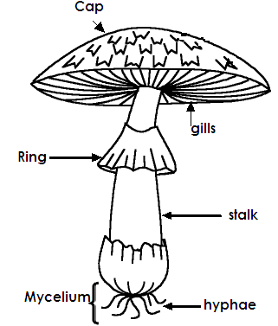
A mushroom

Function of each part
(a) Cap
Protects the gills.
(b) Gills
To produce and store spores

(c) Stipe / stalk
To hold the cap
(d) Hyphae/mycelium
To absorb nutrients from dead decaying matter.
Qn. How do most fungi feed?
Saprophytically
Qn. Write down at least four uses of fungi.
- Some fungi are used as food.
- Some fungi are source of income.
- Some fungi break down organic matter to form humus.
- Some fungi are used to make medicine.
- Some fungi are used in baking bread.
- Some fungi are used in the fermentation process of making alcohol.
Qn. State any two disadvantages of fungi.
- Some fungi cause disease to people and plants.
- Some fungi are poisonous when …………..
- Some fungi make food to go bad.
Similarities between fungi and bacteria.
(i) Both cause diseases.
(ii) Both make food to go bad.
(iii) Both break down organic matter to form humus.
Differences between fungi and bacteria.
(i) Most fungi reproduce by means of spore while bacteria reproduce by means of cell division.
(ii) Some fungi can be seen using our naked eyes while all bacteria cannot be seen using our naked eyes.
(iii) Some fungi are multicellular while all bacteria are unicellular.
Qn. Give two examples of moulds.
- Penicillium
- Mucor
- Rhizopus
Qn. Write down any two plant diseases caused by fungi.
- Panama disease attack banana.
- Leaf rust and leaf spot attack e.g. carrots
- Tomato and potato blight attack tomato and potato.
- Maize rust attack maize.
- Rust fungus affects cereals
- Root rot in tea plant.
- Coffee berry disease in coffee.
Qn. Give any two fungal diseases in people.

- Ring worms
- Athletes foot
- Candidacies
- Finger nail deformation

Prevention and control of fungal diseases.
(i) Re-heating cold food.
(ii) Pickling – dress seeds.
(iii) Spraying plant using fungicides.
(iv) Avoid sharing clothes and combs with infected people.
(v) Bathing daily with clean water and soap.
(vi) Avoid sharing shoes and stockings with infected people.
(vii)Uproot and burn infected plants.
Qn. What is picking?
This is the putting of edible acids like vinegar on food stuffs.
Qn. Write a short note about the following scientists.
- Alexander fleming
He discovered penicillin
- Lous Pasteur
He discovered pasteurization method of preserving milk.
- Sir Ronald Ross
He discovered the cause of malaria.
- Joseph Lister
He discovered antiseptics which prevent wounds from becoming septic.
- Sir William Harvey
He discovered how blood circulates in the body.
(f) Robert Koch
He discovered the cause of tuberculosis
(g) Edward Jenner
He discovered the vaccine for small pox.
Note: He was the first person to be vaccinated – against small pox.
Qn. Name the fungus used to make antibiotics.
Penicillium mould
Qn. How is reproduction in yeast different from all other fungi orgasms?
Year reproduces by budding while other fungi organisms reproduce by means of spores.
TERM THREEE
TOPIC NINE
CHANGES IN THE ENVIRONMENT
Qn. What is a change?
This is the process by which something becomes different.
Qn. Write down the three types changes in the environment.
- Biological changes
- Physical changes
- Chemical changes
1 BIOLOGICAL CHANGE
Qn. What are biological changes?
These are changes that take place in the life of living things.
Qn. Write down the three types of changes in the environment.
- They take place in living thing.
- They are irreversible.
- Young ones grow and become old.
- Small ones change and increase in size.
Examples of biological changes.
(i) Growth in plants and animals.
(ii) Germination
(iii) Shedding of leaves in plants
(iv) Changing colour in a chameleon
(v) Witting of plants
(vi) Flowering of plants
(vii) Fruiting of plants
(viii) Ripening of fruits
(ix) Fertilization
(x) Reproduction .
(xi) Moulting
(xii) Falling sick and recovering
(xiii) Gaining and losing weight.
(xiv) Sweating
(v) Recovering from an illness
Qn. Write down any two examples of physical biological changes in human (people)
(a) In girls
- Growth of pubic hair
- Growth of hair in the armpits
- Development of breasts
- Widening of hips
(b) In boys
- Growth of beards
- Growth of pubic hair
- Growth of hair in the armpits
- Growth of bigger muscles on the chest.
- Pimples on the face
Qn. State any two ways of managing body changes.
- Bathe daily with clean water.
- Promoting proper personal hygiene.
- Having regular physical exercises and soap.
- Shaving the pubic hair and the hair in the armpits.
- Wash under wears daily with clean water and soap.
- Avoid disturbing pimples
- Getting guidance from teachers, parent and other elders.
- Feeding on a balanced diet.
Qn. Mention any two reliable sources of information about growing up.
- Teachers
- Parent
- Sibling
- Uncles and Aunts
- Magazines
- Radio talk shows
Qn. State one advantage of biological in the environment.
Biological changes enable organisms to increase in size.
2. PHYSICAL CHANGES
(a) What are physical changes?
These are changes that are reversible.
Characteristics of physical changes.
- They are reversible
- No new substance is formed.
- There is no change in mass of an object.
Qn. Write down any two examples of physical change.

- Melting
- Condensation
- Evaporation
- Sublimation
- Deposition
- Freezing
- Cracking of an egg
- Changes in weather
- Crushing a can
- Breaking a glass
- Tearing a paper
- Breaking a rock
- Chopping firewood to small pieces.
- Land slides, Earth quake and volcanic eruption

Advantages of physical changes
(i) Physical changes help in rain fall formation.
(ii) Physical changes are used in industries to make useful products.
- Help in mountain formation.
CHEMICAL CHANGES
These are changes that are irreversible.
Characteristics of chemical changes
(i) They are irreversible.
(ii) A new substances is formed.
- There is change in size or weight of an object.
Examples of chemical changes.
(i) Burning of a paper into ash.
(ii) Heating sugar in a sauce pan.
(iii) Souring of fresh milk.
(iv) Rotting of organic matter
- Rusting
- Fermentation
- Respiration
- Digestion
Advantages of chemical changes.
(i) Some chemical changes help in the formation of soil.
(ii) Some chemical changes help to promote sanitation.
(iii) Some chemical changes help to produce energy in the body.
Disadvantages of chemical changes.
(i) Some chemical changes cause pollution.
(ii) Some chemical changes make metals blunt.
(iii) Some chemical change weakens metals.
Other changes include;
(a) Natural changes
(b) People – made change
Natural changes
Qn. What are natural changes?
These are changes that take place on their own.
Examples of natural changes.

(i) Earthquake
(ii) Drought
(iii) Changes in season
(iv) Landslides
(v) Floods
(vi) Lightning
(vii) Changes in weather

Man-made changes
Qn. What are man-made changes?
These are changes caused by man.
Examples of man-made changes.
(i) Man has planted trees.
(ii) Man has built roads.
(iii) Man has constructed bridges.
(iv) Man has cut down trees.
(v) Man has constructed roads.
Qn. Write down any three consequences of various types of changes in the environment.
- Some changes enable living things to increase in size.
- Some changes prevent living things from being wiped out on earth.
- Some changes pollute the environment.
- Some changes destroy life and property.
- Some changes promote sanitation.
- Some changes make tools blunt.
- Some changes spoils fresh food.
- Some changes help in the formation of compost manure.
- Some changes help in rain formation.
POLLUTION
Qn. What is pollution?
Pollution is the addition of harmful substances into the environment.
Qn. What are pollutants?
These are substances that pollute the environment.
Examples of pollutants
- Faeces - Smoke - Urine - fumes from - Garbage
- Factories - Chemicals - Metal scraps - Polythene papers
- Plastics
Types of pollution
- Soil pollution
- Water pollution
- Air pollution
- Sound pollution
Qn. State any two effects of pollution.
(i) Air pollution causes lung cancer.
(ii) Pollution causes acidic rain.
(iii) Pollution leads to death of aquatic animals.
(iv) Pollution leads to death of living organisms in the soil.
(v) Pollution lead to the spread of water borne disease.
Ways of controlling pollution.
(i) Avoid dumping polythene papers in the soil.
(ii) Avoid duping plastics and metal scraps on soil.
(iii) Avoid dumping garbage in water sources.
(iv) Avoid bush burning.
(v) Planting trees
(vi) Setting industries away from people.
TOPIC TEN
KEEPING GOATS, SHEEP, AND PIGS
KEEPING GOATS
A diagram showing external parts of a goat.
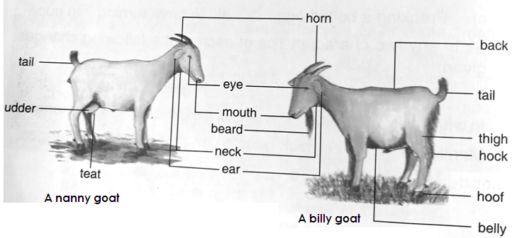

Terms used in goat rearing
1. A nanny goat is a female goat.
2. A billy goat is a male goat.
3. Kid is a young goat.
4. Kidding is the act of giving birth in goat.
5. A wether is a male castrated goat.
6. Castration is the removal of testes from a male goat.
7. Gestation period is the time taken from fertilization to birth.
8. Heat or oestrus period is when the female goat is ready to mate with the male goat.
9. Lactation period is the milking period in animals.
10. Browsing is the free movement of goats as they feed on shrubs and terminal buds of plants.
11. Hoof trimming is the shortening of the goat’s hooves.
Qn. Identify any two reasons why people keep goats.
(i) People keep goats to get meat.
(ii) People keep goats to get milk.
(iii) Goats are source of income when sold.
(iv) People get skins from goats.
(v) Goat droppings are used as manure in the garden.
Qn. Mention the goat product used in leather industries.
Skins.
Qn. Write down at least three examples of leather products.

- Belts
- Shoes
- Wallets
- Tops of drums
- Dancing costumes

Qn. Mention the natural fibre got from goats.
Mohair
BREEDS OF GOATS.
Qn. What is a breed of goats?
A breed of goats a family of goats with similar characteristics.
Breeds of goats reared in Uganda.
- Mubende goats
- The East African small goat
- Boar goat
- Saanen goat
- The Somali goat
- Toggenburg goat
Types of breeds of goats.
(i) Local breeds
(ii) Exotic breeds
Local breeds of goats
These are goats that have been in Uganda for a long period of time.
Qn. Write down any two characteristics of local breed of goats.
(i) They are cheap to manage.
(ii) They need less care.
(iii) They are resistant to harsh weather conditions.
(iv) They are resistant to diseases.
(v) They mature slowly.
Examples of local breeds goats.
- Mubende goat
- The small East African goat
- The Somali goat (Golla goat)
- The boer goat
NOTE:
Local breeds of goats are mainly kept for meat production.
Exotic breeds of goats.
These are goats that were brought to Uganda from other countries.
Qn. State any two characteristics of exotic breeds of goats.
(i) They need a lot of care.
(ii) They mature quickly.
(iii) They are resistant to diseases.
(iv) They are not resistant to harsh weather conditions.
Examples of exotics breeds of goats.
- Saanen goats
- Toggen bug
- Anglo-nubian
- Angora goats
NOTE:
Exotic breeds of goats are mainly kept for mohair production.
Qn. Identify the breed of goats mainly kept for mohair production.
Angora goats
Qn. State any two advantages of local breeds of goats over exotic breeds of goats.
(i) Local breeds of goats are resistant to diseases while exotic breeds of goats are not resistant to diseases.
(ii) Local breeds of goats need less care while exotic breeds need a lot of care.
Qn. Write down any two advantages of exotic breeds of goats over local breeds of goats.
(i) Exotic breeds of goats mature quickly while local breeds of goats mature slowly.
(ii) Exotic breeds of goats produce high quantity of milk and meat while breeds of goats produce low quantity of meat and milk.
Qn. Identify any two ways of improving on the local breeds of goats.
(i) By cross breeding
(ii) By selective breeding
Qn. What is the gestation period of a nanny goat?
5 months (154 days)
Qn. Mention any three signs of heat period in goats.
(i) The goat becomes restless.
(ii) The vulva of a goat swells and changes colour.
(iii) The goat losses appetite.
(iv) The goat urinates frequently.
(v) The goat mounts other goats.
(vi) The goat stands still when mounted.
KEEPING SHEEP
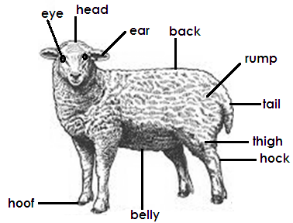
External parts of sheep

Terms used in sheep management.
(a) A ewe is a female sheep.
(b) Ram is a male sheep
(c) Lambing is the act of giving birth in sheep.
(d) Mutton is the meat of a sheep.
(e) Docking is the shortening of the sheep tail.
(f) Shearing is the removal of overgrown wool from the body of a sheep using a shearing machine.
Qn. Give two reasons why people keep sheep.
(i) People get wool from sheep
(ii) People get mutton from sheep.
(iii) Sheep are source of income when sold.
BREEDS OF SHEEP
Types of breeds of sheep

(i) Local breeds of sheep
(ii) Exotic breeds of sheep

Qn. Write down at least two examples of local breeds of sheep.
(i) Black head Persian
(ii) Masai sheep
NOTE:
Local breeds of sheep are mainly kept for mutton production.
Examples of exotic breeds of sheep.
(i) Merino sheep for wool production.
(ii) Romsey March for both wool and mutton.
(iii) Corriedale for both wool and mutton.
(iv) Dorper for mutton
(v) Hampshire down for mutton.
CARING FOR GOATS AND SHEEP
Qn. Mention any two ways of caring for goat and sheep on a farm.
(i) Housing goats and sheep.
(ii) Feeding goats and sheep
HOUSING GOATS AND SHEEP
Qn. Give two importance of housing goats and sheep.
(i) To protect them from harsh weather conditions.
(ii) To protect them from their predators.
(iii) To protect them from diseases and parasites.
Qn. Give a reason why the house of goats and sheep should be well ventilated.
To allow free circulation of air.
Qn. Why should the floor of goats and sheep be made of concrete and slanting?
To allow easy flow of wastes.
FEEDING GOATS AND SHEEP
Qn. Give two examples of feeds given to goats and sheep.
(i) Grass
(ii) Plant leaves
(iii) Banana peeling
(iv) Clean water
(v) Mineral licks
Reasons why we feed goats and sheep.
(i) For proper growth
(ii) To protect them from diseases.
(iii) To increase productivity.
METHODS OF GRAZING GOATS AND SHEEP
(a) Free range grazing
(b) Tethering grazing
(c)Zero grazing
(d) Paddocking
FREE RANGE GRAZING
This is a method of grazing where animals are left to roam about to graze on their own.
Advantages of free range grazing.
(i) It is cheap.
(ii) Animals get enough exercises.
(iii) Animals eat pastures of their own.
Disadvantages of free range grazing
(i) Animals may destroy people’s crops.
(ii) Animals are not protected from bad weather conditions.
(iii) Animals can easily get lost.
(iv) Diseases are easily spread.
TETHERING GRAZING
This is where the animal is tied on a peg or tree stem as it grazes.
Advantages of tethering grazing
(i) There is proper use of pasture.
(ii) It is cheap.
(iii) The farmer chooses good pasture for the animals.
(iv) It is easy to identify a sick animal.
(v) It allows even distribution of manure in an area.
Disadvantages of tethering grazing
(i) The rope may cause injuries to the animal.
(ii) Animals can easily be eaten by their predators.
(iii) Animals do not eat food of their choice.
(iv) Few animals can be kept.
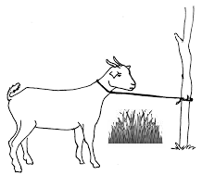
A tethered goat

ZERO GRAZING
This is where animals are kept and fed in their houses.
Advantages of zero grazing
(i) Animals are protected from bad weather.
(ii) Animals are protected from their predators.
(iii) It is easy for a farmer to identify a sick animal.
(iv) Animals cannot easily be stolen.
Disadvantages of zero grazing
(i) Animals do not get enough exercises.
(ii) Animals don’t eat food of their choice.
(iii) It is expensive to maintain.
(iv) It is tiresome to collect pasture.

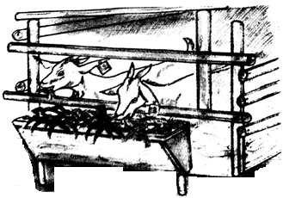
Goats under zero grazing

PADDOCKING
This is the method of grazing where land divided into small plots called paddocks.
Advantages of paddock grazing
(i) It controls soil erosion.
(ii) It ensures proper use of pasture.
(iii) The farmer gets time to do other activities.
(iv) It helps to control parasites.
(v) Grass is given time to grow.
Disadvantages of paddock grazing
(i) It requires a big piece of land.
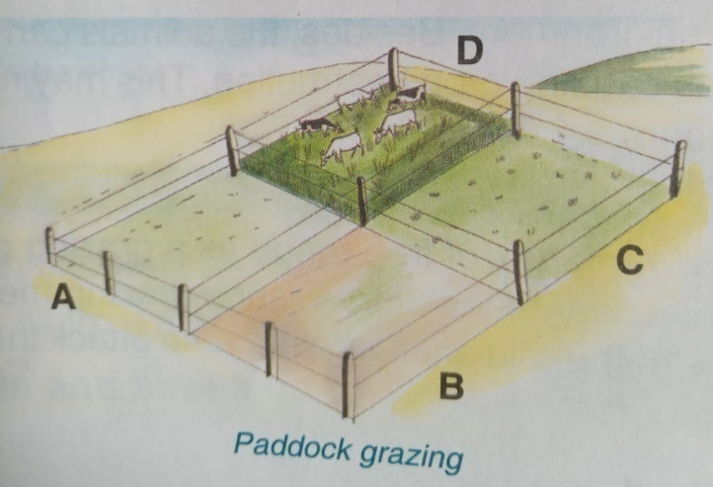
(ii) It is expensive to construct paddocks.

Activities done on a live stock farm.

(a) Hoof trimming
(b) Castration
(c) Docking
(d) Dipping
(e) Spraying
(f) Dehorning
(g) Deworming
(h) Shearing
(i) Dusting

HOOF TRIMMING
Is the shortening of the animal’s hooves
Advantages of hoof trimming
(i) It controls foot rot disease.
(ii) It eases animal movement.
CASTRATION
Is the removal of testes from male animals.
Methods of castration
(i) Open castration
(ii) Closed castration
(iii) Use of a loop
Advantages of castration.
(i) Castration makes the animal to grow fatter.
(ii) Castration makes the animal humble and easy to handle.
(iii) It prevents in breeding
(iv) It prevents inbreeding
(v) It prevents unwanted pregnancies.
(vi) It controls venereal diseases.
Disadvantages of castration
(i) The animal feeds a lot of pain.
(ii) The animal may lose a lot of blood.
(iii) The wound may become septic.
(iv) The animal is denied its natural feeling of having sex.
DEHORNING (DISBUDDING)
This is the removal of horn buds from the head of animal.
Methods used in dehorning
(a) Using chemicals
(b) Using a spoon dehorner
(c) Using a dehorning iron.
Qn. Give two advantages of dehorning.
(i) It creates space on a farm.
(ii) It controls injuries on a farm.
Qn. Give two disadvantages of dehorning.
(i) The animal feels a lot of pain.
(ii) The wound may become septic.
DOCKING
Docking is the cutting short of the sheep’s tail.
Advantages of docking
(i) Makes mating easy.
(ii) Promotes cleanliness in a sheep.
(iii)Docking enables even distribution of fats in the body of sheep.
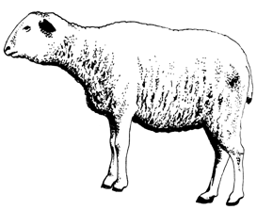
A docked sheep

SHEARING
Shearing is the removal of overgrown wool from the sheep’s body.
Qn. Give a reason why shearing is best done in dry season.
There is enough heat to keep the sheep’s body warm.
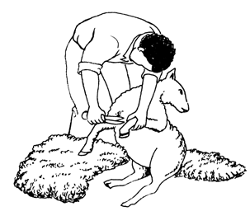
Diagram showing shearing in sheep.

WEANING
- Weaning is the gradual introduction of semi-solid food to young animal in addition to the mother’s milk.
NOTE:
(i) Weaning is done to control diseases in young ones.
(ii) Lambs and kids should be weaned at 4 – 5 months.

PARASITES AND DISEASE OF GOATS AND SHEEP
PARASITES
Qn. What are parasites?
Parasites are organisms that depend on other organisms for survival.
Groups of parasites
(i) External parasites (Ecto parasites)
(ii) Internal parasites (Indo parasites)
External parasites
External parasites are parasites that live on the outside of the body of an animal
Examples of external parasites

- Ticks
- Mites
- Blow flies
- Fleas
- Lice

Ways of controlling external parasites
(a) Spraying animals using acaricides.
(b) Dipping animals in acaricides.
(c) Dusting animals
(d) Practicing paddock grazing

INTERNAL PARASITES
Qn. What are internal parasites?
These are parasites which live inside the body of an animal.
Examples of external parasites.
- Tape worms
- Liver flukes
- Hook worms
Ways of controlling internal parasites.
Deworming animals
DEWORMING
Deworming is the giving of medicine to an animal to kill internal parasites.
Methods of deworming
(a) Dozing
(b) Drenching
NOTE:
(i) Dozing is the giving of solid medicine to an animal through the mouth.
(ii) Drenching is the giving of liquid medicine to an animal through the mouth using a drenching gun.
DISEASES OF SHEEP AND GOATS
Causes of diseases in animals
(i) Germs
(ii) Poor feeding
(iii) Poor hygiene
(iv) Physical injuries
Bacterial diseases
- Pneumonia
- Foot rot
- Lamb dysentery
- Anthrax
- Mastitis
- Brucellosis
- Black quarter
Viral disease
- Rift valley disease
- Foot and mouth disease
- Sheep pox
- Nairobi disease
- Blue tongue
- Rinderpest
Protozoan diseases
- Nagana
- Heart water
- Red water
- East coast fever
- Coccidiosis
Tick borne diseases
- Heart water
- Red water
- East coast fever
PNEUMONIA
Signs and symptoms of pneumonia
- Difficulty in breathing
- Coughing
- Fever
- Loss of appetite
FOOT ROT
Signs and symptoms of pneumonia
- Wounds on hooves
- Rotten hooves
- Pus from hooves
- Limping
FOOT AND MOUTH DISEASE
- Hooves smell
- Hooves develop pus
- Limping
- High fever

LAMB DYSENTERY
Signs and symptoms of lamb dysentery
- Diarrhoea with blood
- Swollen abdomen
- Fever
- Loss of appetite
- Sudden death
ANTHRAX
Signs and symptoms of anthrax
- Shivering
- Weakness
- Blood from all pores of the body
- Loss of appetite
- High fever
- Sudden death
MASTITIS
Signs and symptoms of mastitis
- Swollen udder and teats
- Blood stains in milk
- Pus in milk
- The mother doesn’t allow sucking
BRUCELLOSIS
Signs and symptoms of brucellosis
- Abortion in pregnant animals
RIFT VALLEY DISEASE
- High fever
- Diarrhoea
- Staggering
- Abortion in pregnant animals
NAIROBI SHEEP DISEASE
Signs and symptoms of Nairobi sheep diseases
- Diarrhoea with green and watery stains.
- Abortion
- Discharge from the nose and eyes

NAGANA
Signs and symptoms of nagana
- Eyes become watery
- Fever
- Loss of appetite
- The animal becomes weak
HEART WATER
Signs and symptoms of heart water
- Fever
- Loss of appetite
- Tongue becomes out
- Animals move in circle
Ways of preventing and controlling diseases in sheep and goats
(i) By vaccinating animals.
(ii) Spraying animals using acaricides
(iii) Dipping animals in acaricides
(iv) Hoof trimming
(v) Keeping animal houses clean
(vi) Treating early cases
(vii)Kill and bury all sick animals
(viii) Isolate infected animals
(ix) Apply quarantine
- Regular deworming
KEEPING PIGS
Terms used.
(a) Piggery is the keeping and management of pigs.
(b) A sow is a mature female pig.
(c) A boar is a mature male pig.
(d) A piglet is a young female pig.
(e) A gilt is a young female pig.
(f) A borrow is a male castrated pig.
(g) A litter is a group of young ones born in one birth by the same mother sow.
(h) Farrowing is the act of giving birth in pigs.
(i) Pork is the meat of a pig.
(j) Ham is dry processed meat from hind leg of a pig.
(k) Bacon is the meat from the back of a pig.
(l) Lard is fat from a pig.
(m)Bristles are hair found on the body of a pig.
(n) Runt is the smallest piglet in a litter.
Reasons why people keep pigs.
(i) To get meat
(ii) Pigs are source of income when sold.
(iii) Bones of pigs are used to make glue.
(iv) Bristles from pigs are used to make brushes.
(v) Pigs wastes are used as manure.
External parts of a pig
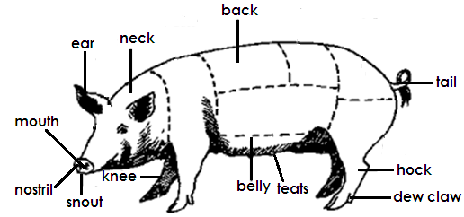

Types of breeds of pigs
(i) Local breeds of pigs
(ii) Exotic breeds of pigs

Qn. Identify any two examples of local breeds of pigs.
- Black pigs
- Spotted pigs
Qn. Write down at least four examples of exotic breeds of pigs
- Large white
- Landrace
- Saddleback
- Hampshire
- Large black
- Middle white
- Poland china
- Berkshire
Management of pigs
Ways of managing pigs
(a) Proper housing of pigs.
(b) Feeding pigs
Housing pigs
A house of a pig is called a sty.
Qn. State any two factors considered when selecting a good site for a sty.
(i) The place should be well drained.
(ii) The place should be near a water source.
Qualities of a good pig sty
- A good pig sty should be well ventilated.
- A good sty should be well roofed.
- A good pig sty should be dry and warm.
- A good pig sty should allow easy observation of animals.
- The floor should be slanting towards one end.
Qn. Give a reason why the floor of a good pig sty should be slanting.
- To allow easy flow of their droppings and urine.
- To allow easy flow of water while cleaning.

Importance of housing pigs.
- The house protects pigs from bad weather.
- A house protects pigs from their predators.
- A house prevents pigs from destroying crops.
Qn. Why are pigs not friendly to too much sunshine?
- Pits have little hair to protect their bodies and yet they have a lot of fats.
Qn. Why do pigs roll in mud during dry season?
- To cool their body temperature.
Qn. What is a crate/farrowing pen?
A crate is a special pen where a pregnant sow is taken before giving birth.
Qn. State the function of guard rails in a farrowing pen or crate.
They prevent the sow from crushing the piglets during suckling.
Feeding pigs
Importance of feeding pigs
(i) For proper growth.
(ii) To protect pigs from diseases.
Types of feeds given to pigs.
(a) Creep feeds given to piglets below and 8 weeks.
(b) Sow and weanes meal given to breeding and weaning pigs.
(c) Finisher or fattener meal given for fattening stock
Qn. Mention any two other things pigs can be fed on.
- Grass
- Sweet potato vines
- Cassava
- Cooked food stuffs
Gestation period of a pig.
Gestation is the period from fertilization to birth.
Qn. What is gestation period of a sow?
3 months, 3 weeks and three days
Steaming up.
- Steaming up is the feeding of a pregnant animal on foods rich in proteins.

Importance of steaming up
- For proper growth of the foetus.
- Steaming up prevents low birth weight.
- Steaming up lengthens the lactation period.
- Steaming up builds the body of a sow in preparation to fallowing.
Qn. Define the following
(a) Colostrum is the first milk produced by female animal just after delivery.
(b) Lactation is the period through which a sow is able to produce milk.
(c) Tooth clipping is the shortening of teeth in piglets.
NOTE:
(i) Colostrum opens up the digestive system of a piglet.
(ii) Tooth clipping prevents piglets from hurting the mother’s teats.
Factors to consider when selecting a good pig for rearing.
(i) Good health
(ii) Hereditary
(iii) Mammary glands
(iv) Good body formation
SYSTEM OF KEEPING PIGS
(a) Intensive system
(b) Extensive system
Intensive system
This is the system in which pigs are kept and fed indoor.
Advantages of intensive system.
- Pigs are protected from bad weather conditions.
- Animals are protected from predators.
- Pigs are kept healthy and free from infections.
- Diseases and parasites are easy to control.
- Pigs grow and mature quickly.
- Animals yield more.
Disadvantages of intensive system.
- It is expensive to maintain.
- It needs close attention.
- It is tiresome to clean the styevery day.
Extensive system
This is the system in which pigs are allowed to roam about and housed at night.
Advantages of extensive system
- It is cheap to maintain.
- Cuts down the costs of feeding.
- Pigs get enough physical exercise.
- Pigs get a balanced diet.
Disadvantages of extensive system
- Pigs can easily destroy crops.
- Pigs can easily be stolen.
- Easy spread of diseases and parasites.
- It is hard to keep health records.
Common parasites of pigs
- Round worm
- Tape worm
- Liver flukes
Diseases of pigs
- African swine fever (Hog cholera)
- Pneumonia
- Swine flue
- Piglet anaemia
- Foot and mouth disease
- Anthrax
- Foot rot
African swine fever
It is caused by virus
Signs and symptoms of hog cholera
- Animals become weak
- High fever
- Loss of appetite
- Staggering
- Bloody diarrhea
- Weakness in hind legs
Piglet anaemia
It is cause by worms and malnutrition
- Weakness
- Rough skin
Swine flu
It is caused by virus.
Signs and symptoms of anaemia
- Fever
- Bleeding from all the body openings.
Ways of preventing diseases in pigs.
- Regular vaccination
- Apply quarantine
- Isolate infected animals
- Regular deworming
- Treat early cases
- Kill infected pigs and bury them.
- Keep the sty clean all the time.
Qn. Why are piglets given anthill soil to the piglets to lick?
To get iron
Starting a livestock farm
Factors to consider before starting a farm.
- Land
- Capital
- Labour
- Market
- Management
FARM RECORDS
Qn. What are farm records?
- Farm records are written information about various activities carried out on a farm.

Types of farm records
- Health records
- Production records
- Breeding records
- Marketing records
- Field records
- Feeding records
Qn. Give two advantages of farm records to a farmer.
- Farm records enable the farmer to plan for the farm.
- Farm records enable the farmer to know his income and expenditure.
- Farm records enable the farmer to know the history of the farm.
- Farm records enable the farmer to know whether he is making profits or loss.
- Farm records enable the farmer be taxed fairly by the government.
Qn(a) Name the tool shown in the diagram below.
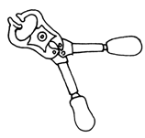

(b) How is the tool named in (a) above useful to piggery farmer?
- For castrating male animals.
TOPIC ELEVEN
FOOD AND NUTRITION
Qn. What is feeding?
Feeding is the taking in of food.
Qn. What is food?
Food is anything good to eat or drink.
Qn. Give two reasons why people eat food.
(i) To be healthy
(ii) To be happy
(iii) To show hospitality
(iv) To satisfy hunger
(v) Some people eat because it is a habit.
Qn. State any two uses of food in the body.
(i) Food help in body growth.
(ii) Food repairs worn out body tissues.
(iii) Food replaces worn out body cells.
(iv) Food provides energy to the body.
(v) Food protects the body from infections.
(vi) Food strengthens bones and teeth.
Qn. What is nutrition?
Nutrition is the study of food and it is used in the body.
Types of nutrition
(a) Saprophytic nutrition is the type of nutrition where organisms feed on dead decaying matter.
(b) Parasitic nutrition is the type of nutrition where organisms depend on other organisms for survival.
(c) Autotrophic nutrition is the type of nutrition where organisms make their own food.
(d) Heterotrophic nutrition is the type of nutrition where organisms depend on already made food.
(e) Epiphytic nutrition is the type of nutrition where organisms live on other organisms but do not obtain food from them.
BREAST FEEDING
Qn. What is breast feeding?
Is the feeding of a baby on breast milk from the mother’s breasts.
Qn. What is breast milk?
Is milk which comes from the breasts.
Advantages of breastfeeding to a baby.
- Breast milk contains all food values needed by the baby.
- Breast milk does not get contaminated easily.
- Breast milk is easy to digest.
- Breast milk boosts the immunity of the body.
- Breast milk is ever ready.
- Breast milk is at the right body temperature.
- Breast feeding creates love bond between the mother and the body.
Advantages of breastfeeding to a mother.
- Breast feeding does not require preparation.
- Breast feeding is cheap.
- Breast feeding is a natural family planning method.
- Breast feeding creates strong relationship between the mother and the baby.
Advantages of breast feeding to a family.
- It is cheap
- The family will have healthy children.
- Family members are not involved in feeding the body.
Disadvantage of breast feeding to a baby.
- A baby may get an infection from a mother.
- The baby may become malnourished if the mother does not have enough milk.
Disadvantages of breastfeeding to a family.
- The mother’s attention is mostly on the baby.
- The breastfeeding mother needs a lot of care.
BOTTLE FEEDING
Qn. What is bottle feeding?
Bottle feeding is the act of feeding babies on milk using a bottle.
Advantages of bottle feeding to a baby.
- Bottle feeding prevents the mother from spreading AIDS to a baby incase she is HIV positive.
- A baby can feed on milk in case the mother is dead.
- Babies with working mothers can feed when their mothers are a way.
- Babies with mothers who have little breast milk and still get milk.
Disadvantages of bottle feeding to a baby
- Bottles or cups get contaminated easily.
- Cow’s milk is not easily digested by the baby.
- Bottles are difficult to clean.
- Cow’s milk doesn’t contain all food values.
- Bottle feeding does not create love bond between the mother and the baby.
Advantages of bottle-feeding to a mother.
- Babies of working mother are able to feed.
- A mother who does not produce enough milk is able to provide for her baby.
- Infected mothers can avoid infecting their babies by bottle feeding.
- It gives time to the mother to do other activities.
Disadvantages of bottle feeding to a mother.
- It encourages early pregnancy.
- It is time wasting.
- It is expensive
- The mother is disturbed at night while a sleep.
Advantages of bottle feeding to a family.
- The baby develops love for most family members.
- All family members are involved in feeding the baby.
- It creates love bond between the baby and family members.
Disadvantages of bottle feeding to a family
- It is expensive
- It is tiresome and time wasting.
Qn. State any two situations where bottle feeding is recommended by doctors.
(i) When the mother is HIV positive.
(ii) When the mother has breast cancer.
(iii) When the mother takes long to come back home.
(iv) When the mother does not have enough breast milk.
Qn. What is exclusive breast feeding?
This is the feeding of a baby on breast milk only for the first six months from birth.
WEANING
Qn. What is weaning?
Is the process of making a child get used to other foodstuffs besides bread milk.
Qn. Give any two examples of food stuffs that can be given to weaning
children.
(i) Porridge
(ii) Mashed Irish potatoes
(iii) Mashed egg yolk
Qn. At what age is weaning done?
At six months
Qn. Why is weaning of children done at 6 months?
- To prevent the child from getting deficiency diseases.
- Weaning enables children to get iron that is not prevent in breast milk.
Qn. What is the recommended time for breastfeeding children?
Two years
Qn. Why should babies be given food frequency?
Babies have small stomachs
Qn. Why should babies be given mashed food?
Babies do not have teeth.
VULNERABLE GROUPS OF PEOPLE
Qn. What are vulnerable people?
Vulnerable people are people who are easily harmed due to lack of a balanced diet.
Qn. Identify any two examples of vulnerable groups of people.
(i) The sick
(ii) The elderly
(iii) Babies
(iv) breast feeding mothers
(v) Pregnant mothers
(vi) Weaning babies
(vii) Invalids
(viii) Convalescents
Caring for vulnerable people
The sick
Qn. An invalid is a person who is ill and cannot take care of his / herself.
Qn. Who is a convalescent?
Is a person who is recovering from an illness.
Qn. State any two ways of caring for the sick.
- Feeding them on a balanced diet.
- By counseling the sick.
- Taking the sick to the hospital for medication.
- Giving the sick medicine as directed by the doctor.
- Helping them to wash their clothes.
- Helping them to bathe.
Qn. Give the importance of the following food values to sick people.
1. Proteins
- To replace worn out body cells.
- To repair worn out body tissues.
2. Vitamins
- To protect the body of a sick person from more infections.
3. Fluids
- To prevent dehydration
4. Carbohydrates
- To get energy
Qn. Why should sick people be given soft foods and soft drinks?
- They have little energy to chew food.
Qn. Sick people eat little food at a time.
- Sick people eat little food at a time.
Elderly
Ways of caring for the elderly people
- By feeding them on a balanced diet.
- By taking them to the hospital for medication.
- By helping them fetch water.
- By helping them to wash their clothes.
Qn. State any two food valves given to elderly people.
- Proteins
- Vitamins
- Fluids
Babies and weaning children
Qn. State any two ways of caring for babies.
(i) By bathing them.
(ii) By breast feeding them.
(iii) By feeding them on mashed food.
(iv) Taking children for immunisation
(v) Washing their clothes.
Qn. State the importance of the following food values to babies and weaning children.
(a) Proteins
- To build the body of a baby.
- For proper growth
- To make enzymes
(b) Vitamins
To protect the body of a baby from infections.
(c) Fluids
To prevent dehydration
(d) Mineral like iron
To prevent anaemia
Pregnant mothers
Ways for caring for pregnant mothers.
(i) By feeding them in a balanced diet.
(ii) Taking them to the hospital for regular checkups.
(iii) By helping them to wash clothes.
(iv) By helping them to fetch water.
(v) Encouraging them to go for ante natal care.
Diagram showing a pregnant mother.
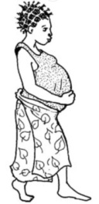

Pregnant mothers need the following food values.
(a) Proteins
- To replace worn out body cells.
- To repair worn out body tissues.
- For proper growth of the foetus.
(b) Vitamins
- To protect the body of the pregnant mother from infection.
(c) Mineral salts
(i) Iron
For formation of blood.
(ii) Calcium
For strong bones
(d) Carbohydrates
To get energy to carry the baby in her womb.
Breast feeding women
Ways of caring for breast feeding mothers.
(i) Feeding them on a balanced diet.
(ii) Taking them for post-natal care to the post-natal clinics.
Breast feeding mothers need the following food values.
- Proteins
- Vitamins
- Mineral salts
Qn. Why should breastfeeding women be given plenty of fluids?
- Fluids help to produce enough breast milk.
Qn. Why should breast mothers be fed on food stuffs rich in calcium?
- To replace the calcium that child is taking in breast milk.
Traditional customs and food taboos in communities.
Qn. What is a custom?
- A custom is a practice which is not acceptable in a society.
Qn. What is a taboo?
- A taboo is a practice which is not acceptable in a community.
Food taboos and food beliefs
Qn. What is a food taboo?
- A food taboo is a cultural or religious custom that forbids people from eating certain types of food.
Qn. Identify any two examples of food taboos.
(i) Moslems are not allowed to eat pork.
(ii) Moslems are not allowed to eat meat slaughtered by a non-moslem.
(iii) Christians are not allowed to eat meat during lent period.
Qn. What is a food belief?
A food belief is a feeding established by certain people to be real or true about food.
Qn. Write down any two examples of food belief.
(i) Women were not allowed to eat chicken.
(ii) Men were not allowed to eat oil nuts.
(iii) Children suffering from measles are not allowed to eat meat.
Advantages of food taboos and food beliefs.
(i) They promote culture.
(ii) They conserve plants and animals species.
(iii) They shape eating habits.

Disadvantage of food taboos and food beliefs.
(i) They lead to gender imbalance.
(ii) They conserve to malnutrition in adults.
(iii) They lead to deficiency diseases in children.
Staple foods for different communities
Qn. What are staple foods?
Staple foods are foods commonly eaten by people in an area.
Qn. Identify the staple food for the following groups of people in an area.
(i) Baganda - Banana (matooke)
(ii) Basoga - Sweet potatoes
(iii) Bakiga - Irish potatoes
(iv) Banyankole - Millet, sorghum and Matooke.
(v) Acholi and Karimojong - Millet and cassava
Qn. What is a totem?
- A totem is a symbol given to a particular clan.

Qn. What is food security?
- Food security is a situation when there is enough food in a home or community for future use.
Ways of promoting food security.
(i) By using good methods of farming.
(ii) By planting crops early before pests multiply.
(iii) By planting drought resistant crops.
(iv) By storing crops in crop stores like granaries and silos.
(v) By spraying crops in the garden to control pests.
Qn. What is food insecurity?
Is when a family or community does not have enough food to eat.
Dangers of food insecurity.
(i) It leads to deficiency diseases
(ii) Food insecurity leads to malnutrition.
Causes of food insecurity.
(i) Crop pests and diseases.
(ii) Poverty
(iii) Drought
(v) Poor farming methods
(vi) Land slides
(vii) Strong winds
(viii) Floods
Advantages of traditional customs
(i) They encourage cooperation among people in a society.
(ii) They promote sharing.
(iii) They promote food hygiene.
Disadvantages of traditional customs
- Some promote gender imbalance.

TOPIC TWELVE
PRIMARY HEALTH CARE
Qn. What is PHC?
- Primary Health Care is the essential care where individuals, families and communities work together to solve their problems.
Qn. Write down at least four elements of Primary health Care.
- Health Education
- Food and nutrition
- Immunisation
- Material and child health care
- Water and sanitation
- First aid
- Dental and oral health services
- Family planning
- Providing skills to Traditional Birth Attendants (TBA)
- Health life styles
- Personal hygiene
- Prevention and control of communicable diseases.
Responsibility of an individual, family and community in promoting health.
Qn. State any two ways how an individual can promote PHC.
- Washing hands before handling food.
- Washing hands after visiting a latrine.
- Brushing your teeth after very meal.
- Washing your eyes.
- Trimming fingernails.
- Ironing your clothing and bedding.
- Bathing everyday
Qn. Write down at least three ways how the family can participate in promoting PHC.
- Attending health meetings or seminars.
- Sharing information among family members.
- Family members should feed on a balanced diet.
- Promoting proper family hygiene.
- Promoting sanitation
- Taking all children in the family for immunization.
Qn. State any two ways how the community can promote PHC?
- Protecting and cleaning water sources.
- Maintaining feeder roads
- Cleaning market places.
- Draining water channels.
- Participating in immunization campaigns.
- Repairing roads to reduce accidents.
- Construction of rehabilitation centres for the disabled.
- Constructing public latrines.
Community hygiene
Qn. What is community hygiene?
- Community hygiene is the general cleanliness of the environment in which a particular community lives.
Activities done to promote hygiene in a community.
- Disposing of rubbish in rubbish pits.
- Burning rubbish.
- Disposing of excreta in the right places.
- Community cleaning sessions.
- Re-using waste plastic and glass containers.
- Making compost manure from organic wastes.
- Protecting water sources
PRINCIPLES OF PHC
Qn. What are principles of PHC?
These are basic rules followed when carrying out PHC activities.
Qn. Write down any two principles of PHC.
(i) Full community participation.
(ii) Health services to the community should be accessible.
(iii) Making decisions
(iv) Socially accepted methods
(v) Total health for every individual, family and community.
(vi) PHC activities should be done according to priorities.
Suitable life styles
- Eating a balanced diet.
- Doing physical exercises during one’s free time.
- Maintaining good body posture.
- Getting enough rest and sheep.
- Avoiding the use of tobacco and alcohol.
- Visiting health workers in case of sickness.
- Having medical checkup regularly.
Good health practices
- Sharing knowledge about health
- Health parades
- Doing regular health committee
- Child-to-child programmes.
HEALTH PARADES
Qn. What is a health parade?
A health parade school children are lined up to check on their cleanliness.
Qn. How is a health parade important in a school?
- Health parade helps children to learn how to bathe.
- A health parade helps children to learn how to comb their hair.
- A health parade helps children to learn how to brush their teeth.
- A health parade helps children to learn how to groom their finger nails.
Qn. Identify any four activities done on a health parade.
- Checking the children’s hair.
- Checking the children’s teeth.
- Checking the children’s eyes.
- Checking the children’s ears.
- Checking the children’s teeth.
- Checking the children’s nails.
Importance of doing regular physical exercises.
- Physical exercises keep the body physically fit.
- Physical exercises keep the muscles strong.
- Physical exercises refresh the brain.
- Physical exercises relieve stress.
- Physical exercises improve the functioning of systems.
- Physical exercises reduce overweight.
A school health committee
A school health committee is a committee composed of teacher, pupils, community health workers and interested parents.
Roles of a school health committee
- It prepares health campaigns.
- It checks the cleanliness of the school environment.
- It helps perfects and teachers to conduct health parades.
- Inviting health workers to talk to the children on health matters.
- Putting in place the materials to use for washing hands.
CHILD-TO-CHILD
Qn. What is child-to-child?
Child-to-child is a programme of activities that teaches how older children can help and care for young children.
Qn. Why is child-to-child important?
(i) CHILD-to-child helps to teach children who have not yet gone to school.
(ii) CHILD-to-child helps to teach who may never go school.
(iii) CHILD-to-child encourages cooperation and sharing.
(iv) CHILD-to-child enables children to share knowledge and skills.
(v) CHILD-to-child enables children to learn how to promote personal hygiene.
(vi) CHILD-to-child enables children to learn good health life style.
Activities in child-to-child
(i) Helping young children to brush their teeth.
(ii) Helping young children to bathe.
(iii) Caring for young children who are sick.
(iv) Helping the disabled children.
(v) Older children taking their siblings for immunisation.
(vi) Playing with young children.

People with special needs in the community and how to care for them.
- The sick
- The elderly
- The babies
- The disabled
The disabled
These are people with disabilities.
Examples of disabled people.
- The lame
- The deaf
- The dump
- The crippled
Ways of caring for the disabled.
- Constructing rehabilitation centres for the disabled.
- Providing the disabled with equipment that enable them to move easily.
- Providing the disabled with skills that can help them to earn income.
- Helping the blind to find their way.
- Communicating to the deaf through gestures and sign language.
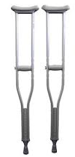
 | 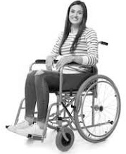
Crutches | Wheel chair

Qn. Besides the above equipments, state any two other equipments that enable people with disabilities to move with less difficulty.
- Artificial legs
- Artificial arms
- Artificial shoes
- Mobility cane / walking stick.

